Circuit drawing of Stepper Motor controller
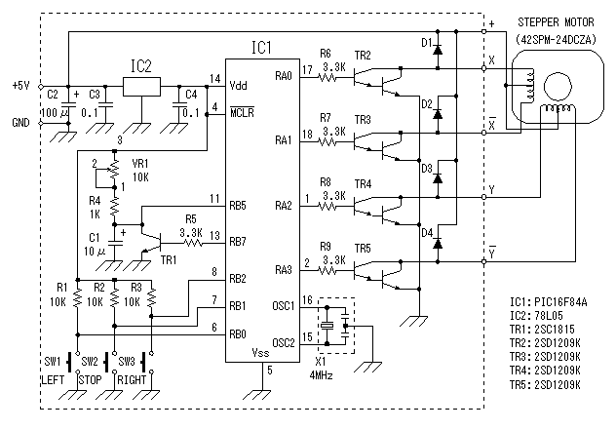

Pattern drawing of Stepper Motor controller
(Wiring side)
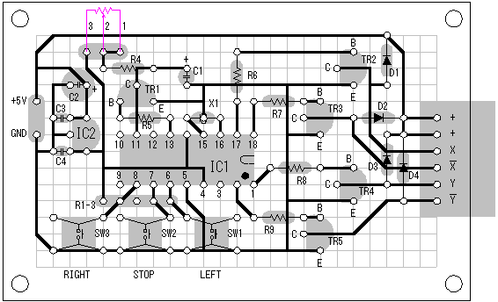
Pink line shows the external parts.
Source code file of Stepper Motor controller
001  002  003  004  005  006  007  008  009  010  011  012  013  014  015  016  017  018  019  020  021  022  023  024  025  026  027  028  029  030  031  032  033  034  035  036  037  038  039  040  041  042  043  044  045  046  047  048  049  050  051  052  053  054  055  056  057  058  059  060  061  062  063  064  065  066  067  068  069  070  071  072  073  074  075  076  077  078  079  080  081  082  083  084  085  086  087  088  089  090  091  092  093  094  095  096  097  098  099  100  101  102  103  104  105  106  107  108  109  110  111  112  113  114  115  116  117  118  119  120  121  122  123  124  125  126  127  128  129  130  131  132  133  134  135  136  137  138  139  140  141  142  143  144  145  146  147  148  149  150  151  152  153  154  155 | ;********************************************************  ;  ; Stepper Motor controller  ;  ; Author : Seiichi Inoue  ;********************************************************  list p=pic16f84a  include p16f84a.inc  __config _hs_osc & _wdt_off & _pwrte_on & _cp_off  ;**************** Label Definition ********************  cblock h'0c'  mode ;Operation mode  ;0=stop 1=right 2=left  count1 ;Wait counter  count2 ;Wait counter(for 1msec)  endc  rb0 equ 0 ;RB0 of PORTB  rb1 equ 1 ;RB1 of PORTB  rb2 equ 2 ;RB2 of PORTB  rb5 equ 5 ;RB5 of PORTB  rb7 equ 7 ;RB7 of PORTB  ;**************** Program Start ***********************  org 0 ;Reset Vector  goto init  org 4 ;Interrupt Vector  clrf intcon ;Clear Interruption reg  ;**************** Initial Process *********************  init  bsf status,rp0 ;Change to Bank1  clrf trisa ;Set PORTA all OUT  movlw b'00100111' ;RB0,1,2.5=IN RB7=OUT  movwf trisb ;Set PORTB  movlw b'10000000' ;RBPU=1 Pull up not use  movwf option_reg ;Set OPTION_REG  bcf status,rp0 ;Change to Bank0  clrf mode ;Set mode = stop  clrf count1 ;Clear counter  clrf count2 ;Clear counter  movlw b'00000101' ;Set PORTA initial value  movwf porta ;Write PORTA  bsf portb,rb7 ;Set RB7 = 1  btfsc portb,rb5 ;RB5 = 0 ?  goto $-1 ;No. Wait  start  ;************* Check switch condition *****************  btfsc portb,rb1 ;RB1(stop key) = ON ?  goto check1 ;No. Next  clrf mode ;Yes. Set stop mode  goto drive ;No. Jump to motor drive  check1  btfsc portb,rb2 ;RB2(right key) = ON ?  goto check2 ;No. Next  movlw d'1' ;Yes. Set right mode  movwf mode ;Save mode  goto drive ;No. Jump to motor drive  check2  btfsc portb,rb0 ;RB0(left key) = ON ?  goto drive ;No. Jump to motor drive  movlw d'2' ;Yes. Set left mode  movwf mode ;Save mode  ;******************** Motor drive *********************  drive  movf mode,w ;Read mode  bz start ;mode = stop  bsf portb,rb7 ;Set RB7 = 1  btfsc portb,rb5 ;RB5 = 0 ?  goto $-1 ;No. Wait  movlw d'5' ;Set loop count(5msec)  movwf count1 ;Save loop count  loop call timer ;Wait 1msec  decfsz count1,f ;count - 1 = 0 ?  goto loop ;No. Continue  bcf portb,rb7 ;Set RB7 = 0  btfss portb,rb5 ;RB5 = 1 ?  goto $-1 ;No. Wait  movf porta,w ;Read PORTA  sublw b'000000101' ;Check motor position  bnz drive2 ;Unmatch  movf mode,w ;Read mode  sublw d'1' ;Right ?  bz drive1 ;Yes. Right  movlw b'00001001' ;No. Set Left data  goto drive_end ;Jump to PORTA write  drive1  movlw b'00000110' ;Set Right data  goto drive_end ;Jump to PORTA write  ;-------  drive2  movf porta,w ;Read PORTA  sublw b'000000110' ;Check motor position  bnz drive4 ;Unmatch  movf mode,w ;Read mode  sublw d'1' ;Right ?  bz drive3 ;Yes. Right  movlw b'00000101' ;No. Set Left data  goto drive_end ;Jump to PORTA write  drive3  movlw b'00001010' ;Set Right data  goto drive_end ;Jump to PORTA write  ;-------  drive4  movf porta,w ;Read PORTA  sublw b'000001010' ;Check motor position  bnz drive6 ;Unmatch  movf mode,w ;Read mode  sublw d'1' ;Right ?  bz drive5 ;Yes. Right  movlw b'00000110' ;No. Set Left data  goto drive_end ;Jump to PORTA write  drive5  movlw b'00001001' ;Set Right data  goto drive_end ;Jump to PORTA write  ;-------  drive6  movf porta,w ;Read PORTA  sublw b'000001001' ;Check motor position  bnz drive8 ;Unmatch  movf mode,w ;Read mode  sublw d'1' ;Right ?  bz drive7 ;Yes. Right  movlw b'00001010' ;No. Set Left data  goto drive_end ;Jump to PORTA write  drive7  movlw b'00000101' ;Set Right data  goto drive_end ;Jump to PORTA write  ;-------  drive8  movlw b'00000101' ;Compulsion setting  drive_end  movwf porta ;Write PORTA  goto start ;Jump to start  ;************* 1msec Timer Subroutine *****************  timer  movlw d'200' ;Set loop count  movwf count2 ;Save loop count  tmlp nop ;Time adjust  nop ;Time adjust  decfsz count2,f ;count - 1 = 0 ?  goto tmlp ;No. Continue  return ;Yes. Count end  ;********************************************************  ; END of Stepper Motor controller  ;********************************************************  end

