Radial Air core alternator Fun!
These are simple radial air core alternators that anyone with a drill and jig saw can build. Below are the basic parts for a single magnet 3 phase alternator...
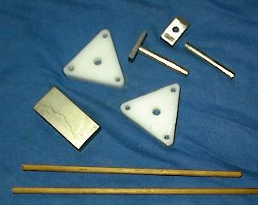
2 plastic triangles sized to match the width of the magnet your using, 1 magnet, some small wooden dowl, 2 1/4" round steel stock ( cut bolts work well ), and some 1/4" bar stock that closely matches the thickness and width of the magnet your using. Also, some copper magnet wire for the coils. Below shows the basic frame assembled...
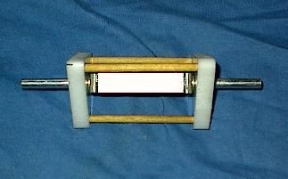
Next you'll wind 3 coils that will fit around the frame...
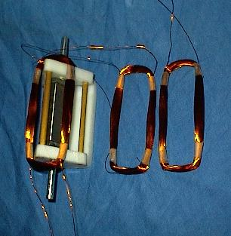
I used 100 turns of #28 wire as an experiment and it worked pretty well but you can adjust the amount of turns you want based on the voltage you need. The more turns, the higher the voltage but lower amps. Basically take all the end wires and connect them together and use the remaining 3 wires as the output.
Lay the 3 coils over the triangles and tape the coils together. It's wired just like a standard 3 phase winding in star ( for higher voltage). Below is the unit completed. Some small plastic spacers were added as stand off's for the base and I simply used wood screws to hold it in place. Great for a mini wind turbine !
Below is a picture of the completed unit...
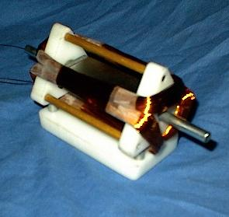
It easily lights LED's as well has the ability to charge nicad batteries... give it a spin !
Want more? Ok, how about a 4 pole radial air core. This one takes a bit of patience and a bit higher skill level but makes a nice 20-50+ watt alternator ...
Here is a shot of the parts you'll need to make...
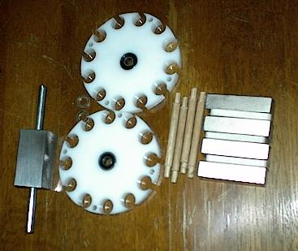
The drilled plastic end plates, 4 wooden dowls, 4 magnets, a solid square steel magnet mounting block ( I used a 1 x 1 inch square steel solid block to match the width and length of the magnets ), a 1/4" shaft and 2 - 1/4" bearings.
The layout and drilling is easy if you make a pattern and tape it to the plastic. Below shows the layout sheet... The large wire holes are 1/2 inch which isn't stated on the drawing.
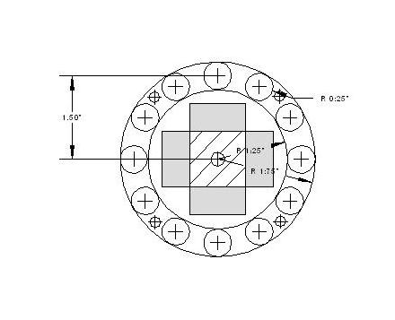
As with the smaller one the assembly is quite simple. Drill through the center of the square block and glue the shaft in place with Jbweld . Glue the magnets to the square block ( N-S-N-S), And your assembly should look like the one below..
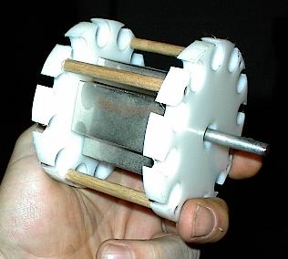
This one you wind the coils in place one at a time. Its wound like a single phase alternator and each phase shares the slot with the next coil. The coils are wound to match the magnetic poles ( clock wise, counterclockwise, clockwise and counter clockwise for each phase ). Start winding in one slot, skip 2 slots and complete the turn in the 3rd opening. I used #20 wire in the one I did using 40 turns per coil. The second and third phase goes in just like the first. It makes it easier if you have 2 - 1/2" dowls to wind the wire around and to remember to skip those slots. Below shows the 4 pole alternator completed...
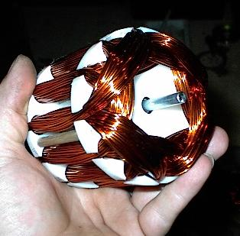
For mounting, you could wrap the outside of the unit in a thin PVC plastic sheet or cut a pipe to fit. Some stainless hose clamps to hold and mount it ! You can also alter the parts to make it a bit heavier duty, such as replacing the 1/4" shaft and bearings with a 1/2" shaft and bearings.
Wiring it is the same, Tie the 3 end wires together for star and the remaining 3 are your output wires... Have Fun!

Mark your start wires and end wires for each phase to make it easy to distinguish them when its completed.

