http://www.extremecircuits.net/2009/07/stereo-to-mono-converter-based-on-fet.html

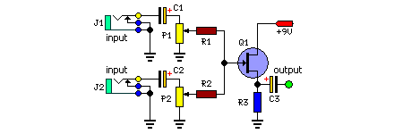

P1 = 10K-50K Pot
P2 = 10K-50K Pot
R1 = 100K
R2 = 100K
R3 = 6.8K
C1 = 0.1uF-25V
C2 = 0.1uF-25V
C3 = 0.1uF-25V
Q1 = 2N3819 Junction FET
J1 = Audio input sockets
J2 = Audio input sockets

