TDA7000 RX FM Receiver

My VHF FM Wireless Microphone project became about the most popular of my transmitters, probably because it is so simple. Here is a very simple VHF FM receiver which is little more than a single IC and a "slack handfull" of capacitors. Note that an external amplifier is a really necessity since the unit only delivers about 70mV of AF.

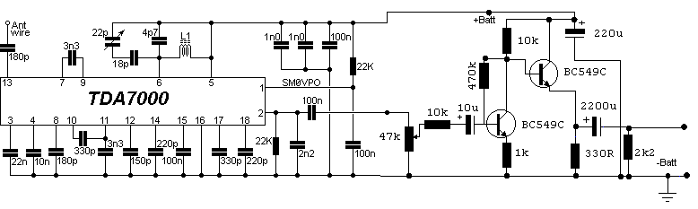

The 10K resistor (*) is only required if you want the receiver to mute (squelch) under no-signal conditions. You could add a 100K in series with this resistor to get an adjustable squelch. This circuit will JUST drive a crystal earphone or high impedance headphones directly, but an output isolating capacitor (100nF) is needed for any other device. L1 is 6 turns No 18 SWG enamelled wire on a 5mm former, but you may have to play with the values a bit. I used a coil fabricated on the PCB itself, tuned with a trimmer capacitor.

All the other components are just a bunch of capacitors which are fitted to the board at the other side of the chip, just to make it look a bit prettier.

SPECIFICATIONS
Specification Min Typ Max
Supply Voltage 2.0v 4.5v 10v
Supply Current - 8mA -
Frequency Range 1.5MHz 88-108MHz 120MHz
Sensitivity (3dB S/N) - 1.5uV -
Sensitivity (26dB S/N) - 5.5uV -
Mute Sensitivity - 6.0uV -
AFC Range (110MHz) - +/-300KHz -
Selectivity 45dB - -
AM Suppression 50dB - -
Max I/P Signal 200mV - -
AF Output - 75mV -

As you can see, this receiver is VERY sensitive, small and seems to work very well indeed. It is in fact a full superhet receiver with a very low RC tuned IF. The Image signal is rejected by the action of the AFC which functions to push it away. With suitable antennas and terrain, with this receiver you could easily get the full 500 meters from the FM wireless microphone v5. I am offering this receiver in kit form, including solder, antenna wire etc. All you will need to provide is the battery, tools and soldering iron. Here is the kit version fully assembled.

The total size is 45mm x 48mm. If there is any interest in the kit then I may even add an AF amplifier kit so that you can make a full bedside/table radio.

Headphone amplifier:

Notes:
Both halves of the circuit are identical. Both inputs have a dc path to ground via the input 47k control which should be a dual log type potentiometer. The balance control is a single 47k linear potentiometer, which at center adjustment prevents even attenuation to both left and right input signals. If the balance control is moved towards the left side, the left input track has less resistance than the right track and the left channel is reduced more than the right side and vice versa. The preceding 10k resitors ensure that neither input can be "shorted" to earth. Amplification of the audio signal is provided by a single stage common emitter amplifier and then via a direct coupled emitter follower. Overall gain is less than 10 but the final emitter follower stage will directly drive 8 ohm headphones. Higher impedance headphones will work equally well. Note the final 2k2 resistor at each output. This removes the dc potential from the 2200u coupling capacitors and prevents any "thump" being heard when headphones are plugged in. The circuit is self biasing and designed to work with any power supply from 6 to 20 Volts DC.

