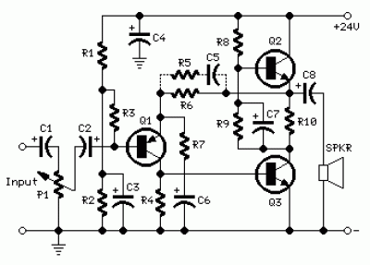
Behaves like a one-valve operated amplifier
Simple circuitry - No cross-over distortion
In the old valve days, most commercial audio amplifiers suited for compact integrated mono or stereo record players used a one-valve amplifier topology. The circuit was usually implemented by means of a multiple type valve, e.g. a triode pentode ECL86.
Common features for those amplifiers were: Class A operation, output power in the 3 - 5W range, input sensitivity of about 600mV for full output power, THD of about 3% @ 3W and 1KHz.
Best types showed THD figures of 1.8% @ 3W and 0.8% @ 2W.
This solid-state push-pull single-ended Class A circuit is capable of providing a sound comparable to those valve amplifiers, delivering more output power (6.9W measured across a 8 Ohm loudspeaker cabinet load), less THD, higher input sensitivity and better linearity.
Related Links Circuit
More circuit Power Amplifier
More about Class A Amplifier
More circuit about OTL Amplifier HIFI
Power Amplifier Class A by Transistor
24 Watt Class A Amplifier by 2N3055
Push-Pull Class A 2A3 Stereo vacuum tube Amp
50W Power Amplifier OCL Mosfet (K1058 + J162)
Parts:
P1_____________47K Log. Potentiometer (Dual-gang for stereo)
R1____________100K 1/4W Resistor
R2_____________12K 1/4W Resistor (See Notes)
R3_____________47K 1/4W Resistor
R4______________8K2 1/4W Resistor
R5______________1K5 1/4W Resistor (Optional, see Notes)
R6______________2K7 1/4W Resistor
R7,R9_________100R 1/4W Resistors
R8____________560R 1/2W Resistor (See Notes)
R10_____________1R 1/2W Resistor
C1,C2__________10ÂµF 63V Electrolytic Capacitors
C3_____________47ÂµF 25V Electrolytic Capacitor
C4____________100ÂµF 35V Electrolytic Capacitor
C5____________150nF 63V Polyester Capacitor (Optional, see Notes)
C6,C7_________220ÂµF 25V Electrolytic Capacitors
C8___________1000ÂµF 25V Electrolytic Capacitor
Q1___________BC560C 45V 100mA Low noise High gain PNP Transistor
Q2,Q3________BD439 60V 4A NPN Transistors
SPKR___________One or more speakers wired in series or in parallel
Total resulting impedance: 8 Ohm
Minimum power handling: 5W
Read More Source:
http://www.redcircuits.com/Page80.htm
Thank you.

