Lead Acid Battery Desulfation Pulse Generator

Some help and information for builders

In the US: Click here for parts kits and assembled units.
In the UK: Click here for parts kits and assembled units from Courtiestown Marine.

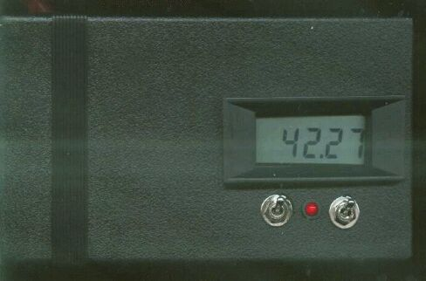
(Last update Mar 4 '06)
This page is intended to provide builders of the battery desulfator circuit, as originally shown in Home Power Magazine, issue number 77, with additional information and very important corrections to the original diagram.
Please note that due to time constraints, I am not able to answer desulfator related questions any longer. I would ask all those needing further assistance to please submit your questions to the desulfator BBS. Thanks for your understanding.
The volume of email has made it clear that a few more details are needed. This circuit has been duplicated by many around the world. (Africa, India, Indonesia.....) Anyone with soldering skills can build the unit. There are many reports of successful battery reclamation after more than a year of testing, so it can be safely said that this technique is valid. While there are a number of commercial units available now, this circuit represents the lowest cost way to rejuvenate tired batteries. I have included complete technical details so that anyone with typical electronics skills can adapt or modify the circuit to their specific needs.
The main concern I have in presenting this information is to keep as many recoverable batteries in service as possible. Most batteries are discarded prematurely, due to sulfation rather than having reached their cycle limit. This represents a huge waste, and a potential resource. It is hoped that many tons of batteries can be kept out of the world's dumps by this simple technique.
- To start with, take a look at this short note on lead acid battery chemistry and the sulfation process.
- Don Denhardt has assembled a gallery of dissected batteries, showing their internal anatomy.
- Here is a patent worth reviewing: Patent #3,963,976 (www.uspto.gov) shows that high peak current is essential to overcome electrolyte stratification.
- Here are a few hints, suggestions, and procedures for reclaiming old batteries.
There are now several versions available, tailored to specific needs:
The original, low power version,  suitable for most solar systems,  vehicle starter maintenance, and  gradual battery reclaimation.  There are several flavors of this circuit. | 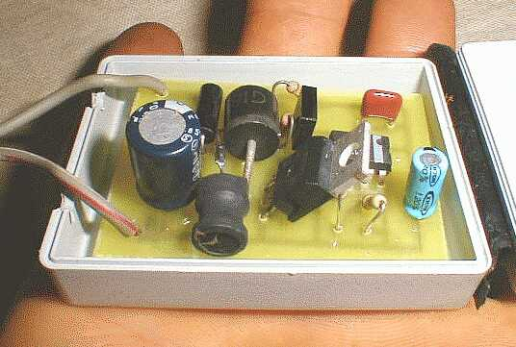
The high power version,  for large battery reclaimation,  electric vehicle maintenance,  high voltage systems, and  low level charging. Under  development. | 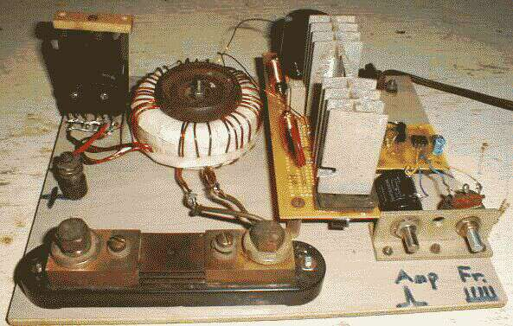

The following provides some supplemental info and links for those interested in theoretical aspects and additional help:
A few words about the "several megahertz resonance" that is mentioned in the original article. One of the most frequent questions is about the fact that the drive frequency is at 1 khz, but the resulting vibrations in the battery are at several MHz. Go back over the part in the article about the "plucked string". This is a very common situation in all systems with a resonant frequency. A disturbance of any sort will tend to create vibrations at the resonance. The megahertz range vibrations are over very quickly, ie they are a damped oscillation. The pulser circuit does not drive these frequencies, any more than a finger nail drives a guitar string at its pitch.
One can see them readily using an oscilliscope, but some care is required to get the triggering just right. A better way to see the fact that batteries have a high frequency resonance is to use a sweep generator, as in the diagram:
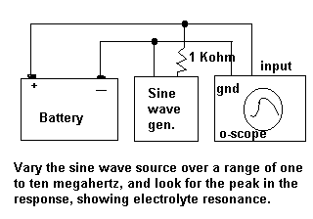
In the original article, I put forth an idea of what might be happening in the battery to cause this resonant frequency, and guessed that it was occuring in the electrolyte itself. An email from battery expert Heinz Wenzl, in Germany, said this:
The next question in my quest to understand this is the following: Given the same battery type there are small deviations of resonant frequency which are no measurement artefact. Now under normal conditions (i.e. the battery not being deep-deep discharged with an acid density close to one), there are always a lot of hydrogen and sulfate ions around which can create a plasma type charge distribution. A change of the frequency could be linked to the electrolyte density which is related to the state-of-charge (I have found no real correlation here), the viscosity (this I would imagine would be linked to the IR spectrum of molecular vibrations), the current exchange density (linked to state-of-charge and surface area and catalytic properties, etc.) and to .... some others. But gut feeling would tell me, that all these effects should be small compared to the plasma properties themselves. In which case, all lead acid batteries with flooded electrolyte should have the same resonance and NiCd a different one.
What makes you think that the plasma condition is associated with the electrolyte and not with the solid material? Some lead minerals, e.g. PZT are piezoelectric and the few Mhz are really in that range of effects!
So my original guess about what may be going on was not very close to the mark. Nevertheless, the resonance is very much there, and it helps to create conditions of high peak voltage (ringing) that are favorable to the process of desulfation.

Does this really work ?
The results are coming in. Here are some typical comments:
- Hello Alastair, I would like to thank you for such a neat product. I have reclaimed several batteries now that were junk. I have gathered up as many more as I can find and have them connected to an Air 403 for charging and running of the desulfator. Free batteries and free power, doesn't get much better than this. I have built several other desulfators for other people to use ..... thanks again for such a fantastic project. Ed Goddard Castle Dale, Utah.
- I am pleased with the performance. Yours works faster than the $90 Pulse Tech unit I've had 3 years. George Ficklen Newport News, Va.
- I can actually see etching into the sulfate crystals on top of the cells. Eric Wiggins. Thames, N.Z.
- It looks as though this little device saved me $60.00. The white deposits have all but disappeared on the plates. Scott Sisson. Portland, Or.
A number of comments on the message board have been about battery testing. Here is a response from Geoge Aumann:
Using a resisitive load to measure battery condition is a standard method. For each battery type a standard load is defined, and if the voltage under load drops below a certain level, the battery is bad or in need of recharging. For small batteries this load can be typical, like a 5 Ohm load for a AA Alkaline drops the voltage at end-of-life to 1.0 Volts. Using a load across the battery (for a few milliseconds) is used by laptop computers to assess the charge status of the battery.
For big batteries the "standard" load resistor may get to be very small. However, given the availbility of good and fairly cheap(under $40) 3 1/2 digit digital volt meters, it is not necessary (or safe) to draw a big current spike out of the battery to measure its internal impedance. For my Dynasty UPS12-310 High output battery I use a 1 Ohm 1% 20 watt resistor shunted with a bar directly to the battery terminals. The resulting drop across the 1 Ohm resistor is eazy to measure with the voltmeter set to the 200 mV scale.
A fully charged 12.6 volt lead-acid battery will have an internal resistance of about 0.01 ohms. My Dynasty UPS12-310 high output battery is spec'd at 0.0033 Ohm. Determine the internal resistance of the battery by measuring the terminal voltage with open circuit, V, and then the voltage drop across an accurately known resistive load R, voltage DV. The internal impedance of the battery, Ri, is then given by Ri= DV * R / V.
Example: V=12.60 volts and DV= 81 mV Volt using a 1 Ohm 1% 20 watt Ohmite resistor. Ri= 0.081* 1.0 / 12.6 = 0.0064 Ohm.
The power dissipated in the resisitor is V*V / R = 12.52 * 12.52 = 158 watt. The resistor will get warm very quicky. If this experiment is not finished quickly, the temperature increase will change the resistance. This will make the measurement inaccurate and will burn your fingers).
Somebody on the email suggested pulling 200A, presumably using a 0.062 Ohm resistor. Pulling that much power (200 * 12.6 = 2.5KW!) has to be done fast indeed. Batteries of this size can be very dangerous.
If you would like to communicate with others in this project, or to ask questions not answered by the above material, please try the
desulfator bulletin board.

Some relevant links:
Commercial Desulfator from Solar-Electric.com
Technical details on why pulse charging is good.
This shows that Ni Cads are similarly benefitted
Here is an email exchange on battery testing techniques.
A Battery Tester by Megger
http://www.btechinc.com/ Another battery tester.
http://www.powerdesigners.com/InfoWeb/design_center/Appnotes_Archive/A2615.shtm Further Battery testing info.
http://www.batterybes.com/ Commercial desulfator.
http://www.van-haandel-1.mywe b.nl/Download.html An article in Dutch about a desulfator with some interesting features. See page 2 for the schematic. Here is a translation to English of the most important details.http://users.pandora.be/vandenberghe .jef/battery/

The Low Power Desulfator

Help and information for builders
(Last update May 4, '02)
- This page will give assistance to builders of the desulfator circuit shown in Home Power magazine, #77. The circuit has been tested sufficiently to know that it is effective on 12 volt systems up to 1000 amp-hours, and possibly higher. It can be used in automobiles with starter batteries that have become marginal. Most small solar systems will also be benefitted. It is very simple and easy to duplicate.
- Schematics:All the following circuits work quite well. There are some parts that may be easy or hard to get, so you can pick the one that suits you best.
  - Here is the pulser circuit from Ron Ingraham. It uses an N channel FET, which is easier to locate for many people.
  - Here is another 555 alternative schematic from Don Denhardt.
  - I had no idea that P channel units were hard to come by, but my original circuit from the article, using the P channel FET, is here. Thanks to Glenn Brown, we have single sided PCB layouts. Here is the trace layout: traces.gif. Here is the placement grid grid.gif. And here is the nomenclature: parts.jpg
  - Here is another N channel version from Trevor Andrews in the UK, by way of the BBS discussions. It has some EU parts designations. The 555 will not handle very high voltages, so be careful not to use on open circuit batteries. For utter simplicity, here is a blocking oscillator that Trevor also uses.
  - Alastair Evans in the UK sends his N-channel version which has some additional protection. Here is the double sided layout for etching a circuit board: TOP and BOTTOM. He also has some release notes as well. Thanks !
- It is possible to use a simple peak detector across the battery to watch the progress of desulfation. as the battery internal voltage goes down, so will the peak voltage which the pulser develops across the battery. Here is a simple circuit from Trevor A.
- There is now an FAQ for additional helpful hints. Also, the desulfator bulletin board is available to ask any more unusual questions.
- Don Denhardt has taken the initiative to put together some parts kits to make it easier for home builders. He has this circuit designed at 12, 24, and 36 volts. He has also begun development of a Stamp based, intelligent desulfating circuit. The Stamp module is a microcontroller chip that runs BASIC and hooks directly to the serial port of a PC. This allows for many different possibilites, and anyone wanting to experiment in this area has a great open opportunity availiable. Click here for Don Denhardt's parts kits.
- Note: The value of C2 is wrong in the original article. It should be .0022uF, not .022uF. This explains why some have had problems with frequency/ pulse width being off.
- I have used parts from Digikey.com, and also from Mouser Electronics. The only item that is remotely critical is the inductor L1. I have used a variety of inductors taken from old switching supplies and TV chassis, and they all work fine as long as they are somewhat close to the value indicated, have low enough series resistance, and that the output of the 555 timer is trimmed accordingly. If you have a larger valued inductor, you would lengthen the pulse width, if you have a smaller value, you would decrease the width. Read below for more about this. L2 is totally noncritical, as long as it doesn't get too warm at the current level you are using. It's purpose is simply to isolate the current pulse from the rest of the circuit, and to control the current going into C4. More on this below.
- The MOSFET can be any unit that has a sufficiently low "on resistance" rating. Power dissipation is low, but I use a high power unit to lower this resistance, as that is part of what limits the peak pulse current generated. The voltage rating needs to be high enough to stand the highest peak voltage, which might get to be 100 volts. If you want to try for higher peak currents, you can parallel MOSFETS together, as they share current well.
- The diode D1can be anything that is fast, has a high peak current capacity, and more than 100 volts peak inverse rating. Again, the higher current devices are not required by the circuit, but they will help to increase the peak current by virtue of low resistance.
- The output leads should be made from fairly heavy wire (#16 or less) and be as short and direct as possible.
- Here are some hints for making higher voltage versions. The same principles apply.

Begin by making sure the 555 is putting out the proper drive waveform to the MOSFET. This is best done with a scope. Using trim pots in place of R1 and R2 will allow for a wide range of conditions and battery types to be accommodated. If you are unfamiliar with 555 operation take a look at this tutorial: http://courses.ncsu.edu:8020/ece480/common/htdocs/480_555.htm. The illustration below shows what the drive signal to the P channel FET should look like (note: invert this waveform for the N channel version) :
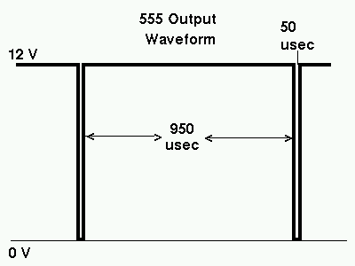
The frequency of the pulse is close to 1000 Hz. The width of the narrow, negative going part controls how long the MOSFET is turned on. The longer it is turned on, the higher is the peak amperage delivered to the battery, up to a point. At present, it isn't known whether it is better to pulse frequently with a small amperage pulse, or whether a slower, higher peak pulse is better. I am leaning towards the latter at the moment, as a result of the content of this patent.
NOTE:If you are having trouble with things getting too hot, it is likely that the 50usec pulse width is too long, resulting in L1 saturating. Also, C4 should not get warm, but will if it is a marginal unit with too much ESR (effective series resistance).

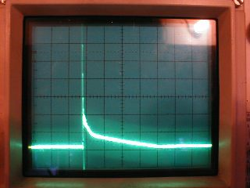
Here is the current pulse created by the circuit. This was taken using a .1 ohm resistor in series with the negative lead. The circuit is showing, given the scope setting, a peak current of over 5 amps. There is quite a bit of high frequency ringing on the leading edge of the pulse. This peak current can be reduced or increased by changing the width of the 555 drive pulse to the MOSFET. For small batteries, it might be wise to reduce the pulse width. For larger units, using heavier duty inductors, a longer pulse would give more current. As the 555 goes low for ~50usec, the MOSFET is turned on. Current flows into L1 from the stored charge in C4. The magnetic field around L1 builds up until Q1 turns off. The field now collapses, and as a result the inductive kick back forces a large current spike which goes from the -12 volt terminal, through D1, through L1, through C4, and into the +12 volt terminal. This is all over in less than 100 usec. The rest of the cycle allows C4 to slowly recharge, at a current of around 50 mA, through L2 until the next firing of Q1. Check the DC current drain of the circuit. It should be less than 100mA, preferably less than 50mA. If you increase the peak current output, the efficiency will go down, and so the DC current drain will go up.
The tireless Don Denhardt has supplied the following data which shows, for the Delevan chokes sold through Digikey, the relation of pulse width to peak current pulse. It shows the diminishing returns due to saturation of the inductors:
Tables showing peak amps
at various pulse widths.
(Pulses in microseconds.)

6 Volt battery

IRF=IRFZ44N
IRL=IRLZ44
L1=(See table)
L2=1000uH

Pulse IRF IRL IRF IRL
Width 220uH 220uH 120uH 120uH

10 .75 .75 0.8 0.8
20 1.2 1.0 1.2 1.2
30 1.6 1.3 1.8 1.6
40 2.0 1.8 2.0 1.8
50 2.2 1.8 2.2 2.0
60 2.4 2.0 2.6 2.2
70 2.8 2.1 2.8 2.5
80 2.9 2.2 3.0 2.8
90 3.0 2.5 3.6 3.1
100 3.2 2.8 4.0 3.8
110 3.6 2.9 4.0 4.0
120 4.0 3.3 4.0 3.9
130 4.6 3.8 --- 3.8
140 5.0 4.2 --- ---
150 5.1 4.5 --- ---
160 5.0 4.6 --- ---
170 5.0 4.5 --- ---
180 4.9 4.1 --- ---

12 Volt battery

IRF=IRFZ44N
IRL=IRLZ44

Pulse IRF IRL IRF IRL IRF
Width 220uH 220uH 120uH 120uH 330uH

10 1.2 1.0 1.5 1.2 0.8
20 1.9 1.6 2.2 1.8 1.2
30 2.4 2.0 3.0 2.4 1.6
40 3.0 2.5 3.5 3.5 2.0
50 3.5 3.0 3.5 4.0 2.2
60 4.0 4.2 3.2 4.0 2.5
70 4.0 4.8 --- --- 3.2
80 4.0 4.8 --- --- 3.5
90 4.0 5.0 --- --- 3.5
100 4.0 5.0 --- --- ---

back to Desulfator Help Page

High Power Desulfator

Beta level Circuit
(Updated April 11, 2002.) The following circuit is looking like it will give good results for large battery banks, as it is putting out ~200 amp pulses at 12 volts. While I am not necessarily recommending this high level, it should answer the needs of the biggest of banks. This will also give a low level charge of a few amps, given the low rep rate. It is still being tested at the moment, but I do not expect large departures from this basic layout.
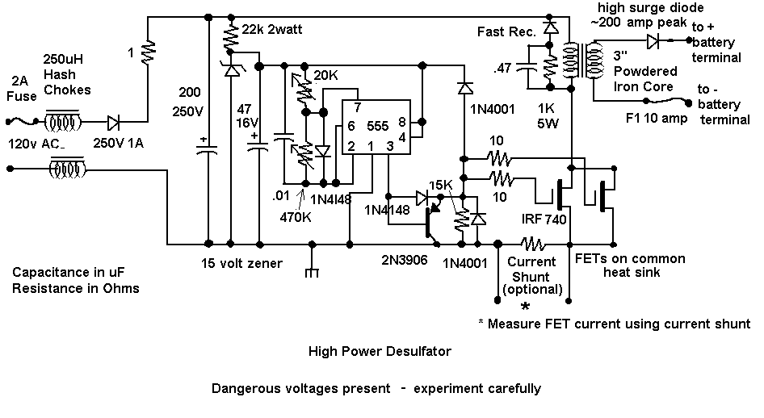
Here are some design factors and parts suggestions, starting from the left:
- The circuit runs directly off line power, no transformer. This means dangerous voltages are present ! Experiment carefully. The 1 ohm resistor is to limit inrush current when turned on. The fuse should be a slow blow type. The hash chokes are for reduction of radio interference. The circuit would be best built in a shielded box if this is a concern.
- The driver circuit runs off of high voltage stepped down and regulated. The zener and the 22k resistor will get warm during operation, but not hot. If they get too hot, increase the 22k.
- The 555 circuit is much the same as with the low power pulser. I now use the enhanced turn off circuit contributed by Ron Ingraham, as it is simplest. Since the drain current is zero when the FETs turn on, it does not matter if the drive is slower at that point. Only turn off speed matters for maximum effect. The pulse width is anywhere from 10 to 100uSecs, depending on what is desired for peak output current.
- The output FETs are paralleled together on a common heat sink. They get only slightly warm during operation, so it does not need to be large. At the moment I am using 3 IRF740's, this is probably on the safe side as they do not get warm. Other FETs can be used if they have low on resistance and a 400 volt rating.
- The snubber circuit uses a fast 200V diode, a 1k 5W resistor, and a .47 250V capacitor. This is a traditional approach to limiting peak transients, and works well enough. The dissapation here can be reduced as the transformer is further optimised.
- The transformer is wound on a core from Bytemark. It is powdered iron, 3 inches in diameter, part number T-300A-26. One could probably use the next size down as well. The primary is at the moment 60 turns of no. 18 to 20 enameled wire. Cover the primary with a layer of insulation, preferably of transformer tape (or at least not black electrician's tape.) There are four secondary windings of ten turns each, no.12 or14 wire. They are wound in "quadra-filar" fashion, which means they are placed side by side and wrapped around together in the form of a ribbon. The windings should all be evenly spaced and spread uniformly around the circumference of the core. This is done to reduce stray inductance. Note the polarity of the windings. All the windings are done in the same direction. The primary lead which connects to the high voltage line will be a beginning point. The secondary winding which connects to the diode will therefore also be a beginning point. If the polarity of the secondary is reversed, then you will not get a proper current spike. Here is a diagram to show this:
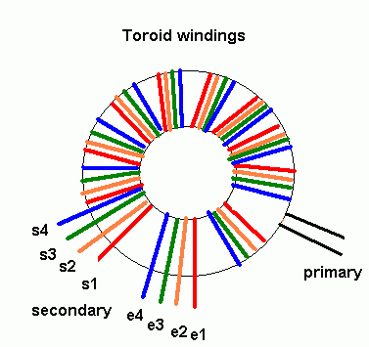
- For 12 volt batteries, use all the secondaries in parallel, ie. S1, S2, S3, S4 are all tied together, and E1, E2, E3, E4 are all tied together. For 24 volt batteries, use series connections to increase the voltage, just like a normal transformer. This means use the windings in pairs, and connect the ending of one paired winding to the beginning of the other, ie S1-S2 is connected together, E1-E2 and S3-S4 are all connected together (the center tap, which is not otherwise used), and E3-E4 are connected together. For 48 volts systems, use the four windings in series, or S2 to E1, S3 to E2, S4 to E3, S1 and E4 are the output leads. Note that the peak current will be reduced at the higher voltages. For 120 volt EV batteries, a more straightforward 1:1 transformer should work, with primary and secondary each made with #12 wire. The windings would be made in bifilar fashion.
- The output rectifier is a high current, reasonably fast type. At the lowest voltage, a Schottky diode, such as the 60 amp 45 volt STPS6045CW from ST Microelectronics gives good efficiency. (Mouser catalog part no. 511-STPS6045CW) . Mount it on a small heat sink. At higher voltages, try a 20 amp 100 volt STPS20H100CW, which has lower current but higher voltage rating. They can be paralleled for higher current. At the highest voltages, 400 volt, 35 amp fast recovery units are needed. It is important to have a load connected before applying power, otherwise the FETs could receive a damaging spike.
- The theory behind this type of circuit can be seen on this page of DC to DC converter designs.
Adjust the circuit with the variable resistors on the 555: The 470K resistor adjusts rep rate, and should be set to less than 1kHz. The 20k resistor is pulse width, and should be set such that the transformer core is not starting to saturate- in the neighborhood of 100 usecs. The circuit as a whole should draw around .2A @ 120VAC or less. In my tests on the bench I can get over to 200 A peak current out at low voltage. Less peak current will be possible at the higher voltages. However, one only needs to duplicate the transformer, and add more FETs in parallel to get further increases in peak power.
Be careful in probing the circuit with a scope. I have been advised that a half wave rectifier, at the line input, should be used so that people won't get confused by creating ground loops with scope probes, etc. It seems that the full wave bridge is not really needed as ripple is not much of a concern with this circuit. Make sure that you observe correct polarity at the mains connection point, so that ground is indeed grounded.
For those who wish to drive this circuit from a microcontroller chip, use an optocoupler for protection. The following diagram will enable a simple logic level interface, using the Isocom H11L2 (from Digikey.) This unit has a strong pull down output, and is reasonably fast. Other types will be fine, as long as they have a low turn current input(10mA or less) and a fast darlington or schmidt trigger output.
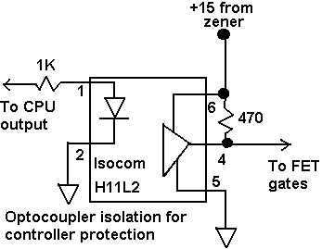
This page will be updated as time and interest permit further progress to be made. Experiment with care.
back to Desulfator Help Page

