Solar garden light - Solar Cell charges single NiCd AA cell which runs LED via stepup converter when darkness falls HOME

Reverse engineered circuit diagram of a popular mass produced solar light. The light automatically turns on when there is no light falling upon the solar cell, so the parts count is minimal. The charging circiut is not particularly efficient since the battery must charge through a plain diode.
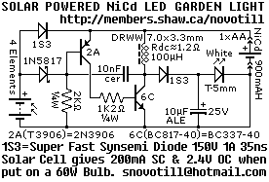
Another Reverse engineered circuit diagram of a mass produced solar LED light. This light also automatically turns on when there is no light falling upon the solar cell but this circuit waits untill it gets bit darker outside than the one above. Although battery charging is through a schottky diode, some charging efficiency is lost in the 330 ohm resistor during daylight time.
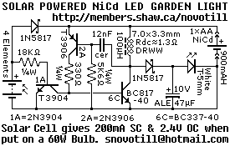
Reverse engineered circuit diagram of yet another commercially produced solar garden lamp. This one depends upon a CDS photocell to turn the light on at night, and although more complex than the circuits, it allows the battery to charge more efficiently.
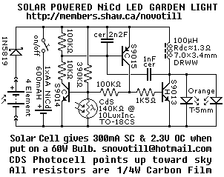
Reverse engineered circuit diagram of one more commercially produced solar lamp. This one is very similar to the one above, but it is brighter and contains an extra capacitor.
