Method of upgrade
- Work before upgrade
In order to save the files in your MP3 player, please connect your mp3 by USB cable with computer and copy the files in your mp3.
2. Method / Step of upgrade：
There are 2 ways to upgrade mp3/mp4, maybe different model shares different way.

The first way (If your player could not be open)

Turn off mp3 (if your mp3 have ON/OFF button, please push the button to the OFF
- Press POWER key for a moment until you connect MP3 to computer by USB interface。
- PC will find‘rockusb Device’，and ask you to install the upgrade tool in CD，If you have installed the upgrade tools in your PC, pleases skip the 3rd and 4th steps ，refer to the below picture:
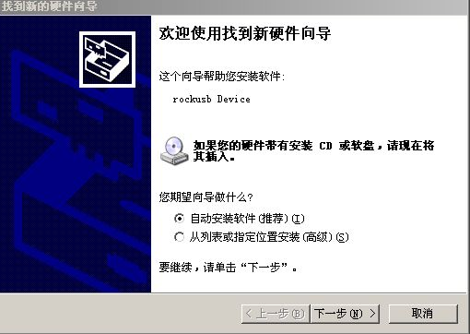
- Install driver in CD：
a、Choose the place to install the driver of CD and start the “next step” 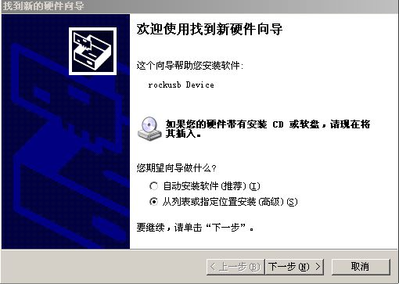
b、 Choose“skim”
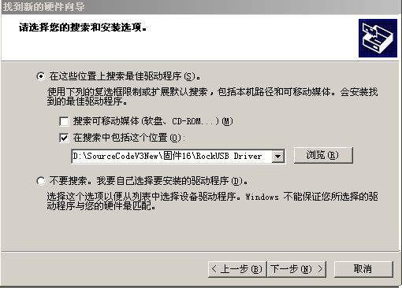
c、Find out“RockUSB Driver” in the folder，choose“confirm”；
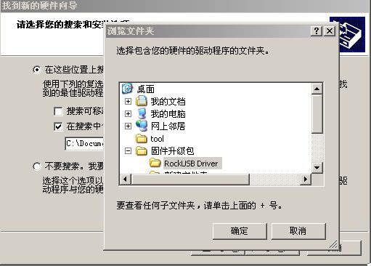

d、Choose“next step”，system will install the driver software ，the following dialog box will display (see the follow photo)，choose“browsing”，then choose“rockusb.sys”to continue install file；
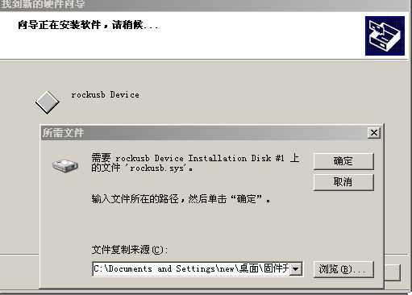
e、Install finished。
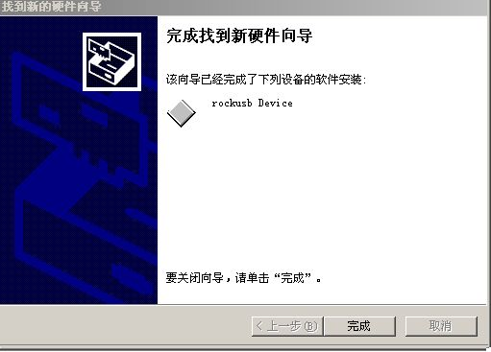

- Run firmware upgrading program：double beat Consumer_WS.exe
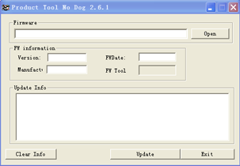
- choose“open”，choose firmaware（.rfw file）；
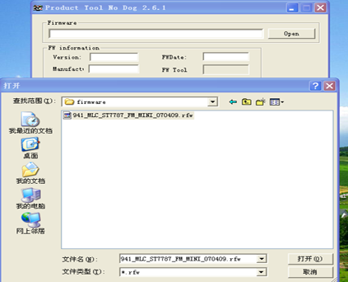
- Following information will display；
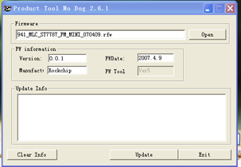
- choose“burn firmware”button
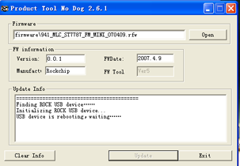
- Disconnection MP3 with PC after upgrade.
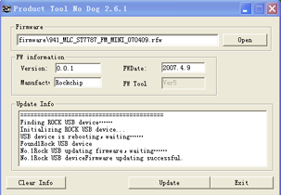
The second way to upgrade player：
1. Turn off mp3 (if your mp3 have ON/OFF button, please push the button to the OFF
- Turn on mp3 again, press “PLAY” key to turn on mp3，enter “system setting of “menu setting”，then choose “firmware upgrade”， press“confirm”and then connect MP3 with PC。
  - The remainder step is the same as the steps from 3 to 9 in the 1st upgrade method.

3. Following questions will happen
1、Upgrade program could not find out ROCK USB，as follows：
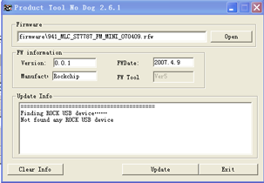
The reason is that MP3 could not be smoothly connected with PC to execute upgrade，please try again.
If connect smoothly, please choose of “USB device” at the below of right corner of PC, the following will display:
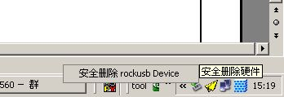
- PC will advise you“NAND FLASH is not supported”：
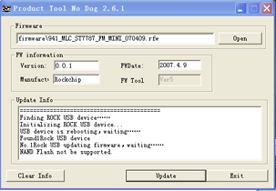
It is possible that there is something wrong with “NAND FLASH”，may try to upgrade again. If there still exist question, please kindly check if there is something wrong with NAND FLASH。

