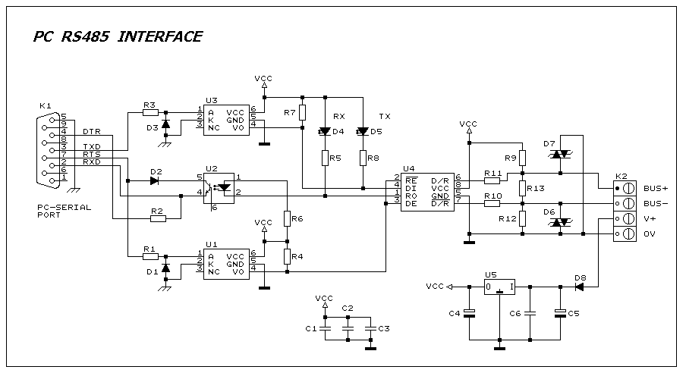

1 4 C1,C2,C3,C6 100nF
2 1 C4 10uF 16V
3 1 C5 470uF 25V
4 3 D1,D2,D3 1N4148
5 2 D4,D5 LED RED 3mm
6 2 D7,D6 TRANSIL 6.8V
7 1 D8 1N4003
8 1 K1 DB9 R/A PCB PLUG
9 1 K2 PCB TERMINAL BLOCK 4 WAY
10 3 R1,R2,R3 1K8
11 2 R7,R4 4K7
12 2 R5,R8 1K
13 3 R9,R12 150R
14 1 R6 680R

