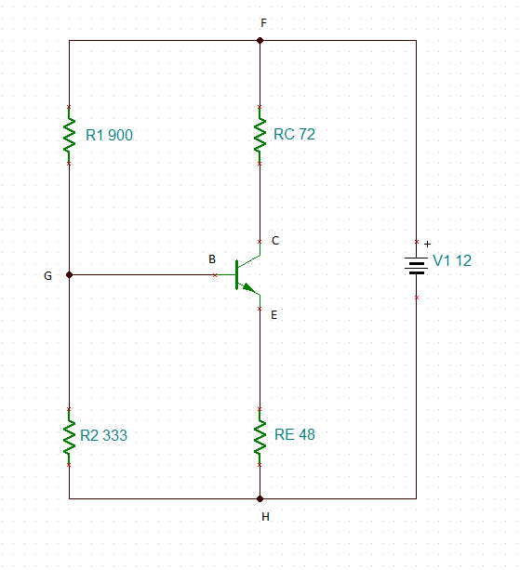
U_{HF}=12V; U_{CE}=6V; h_{fe}=50; I_{FC}=50mA; U_{BE}=0,6V; U_{BH}=3V
I_{FC}=(U_{HF}/(R_{C}+R_{E}))/2 -> R_{C}+R_{E}=U_{HF}/(2*I_{FC})=12/0,1=120ohm
I_{GB}=I_{FH}/h_{fe}=0,05/50=0,001A=1mA
I_{FG}=10*I_{GB}=10*0,001=0,01A=10mA
R₂=U_{BH}/(I_{FG}-I_{GB})=3/(0,01-0,001)=333,33ohm
R₁=(U_{HF}-U_{BH})/I_{FG}=(12-3)/0,01=900ohm
R_{E}=(U_{BH}-U_{BE})/(I_{FC+}I_{GB})=(12-3)/(0,05+0,001)=47ohm
R_{C}=120-R_{E}=73ohm

