http://www.lcdparts.net/TransformerDetail1_E.aspx?PartNumber=8TC00332
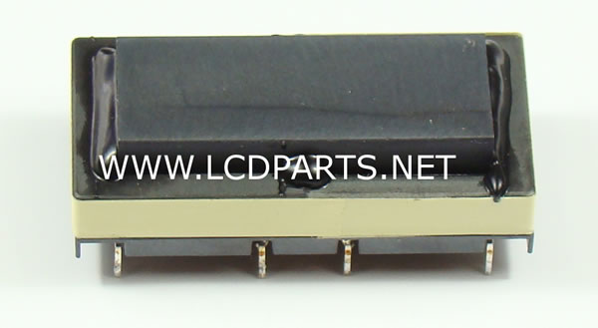
Description | This new replacement transformer is made by MoniServ. It is for Darfon Inverter. The secondary resistance is about 1.0 K between S1 and S2 (or S3 and S4). The primary resistance is about 0.3 ohm between P1 and P2 (orP3 and P4). this transformer is used on FPS055-2PI02A LIPS inverter.
Part Number | 8TC00332
Price | 21.9900
Secondary Resistance | 1.0 K
Primary Resistance | 0.3 ohm
