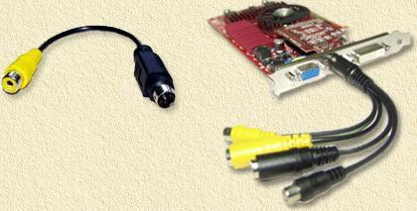
TV-Out cables: simple and complex
S-Video
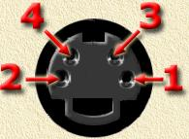  4-Pin variant |  |  | 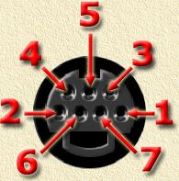  7-Pin variant
S-Video connector pinout (female)
Pin | Signal
1 | Ground
2 | Ground
3 | Luminance
4 | Chrominance
5 | -
6 | Composite Video
7 | Ground

