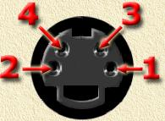
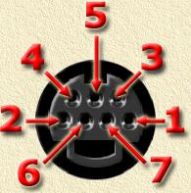
S-Video connector pinout (female)
4-Pin variant 7-Pin variant
Pin Signal
1 Ground
2 Ground
3 Luminance
4 Chrominance
5 -------------
6 Composite Video
7 Ground
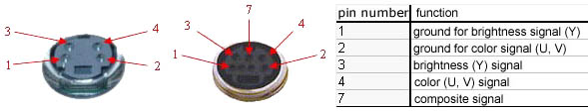
S-video foglalatok

