Precision Audio Millivoltmeter
source: RED Free Circuit Designs

Measures 10mV to 50Volt RMS in eight ranges
Simply connect to your Avo-meter set @ 50΅A range

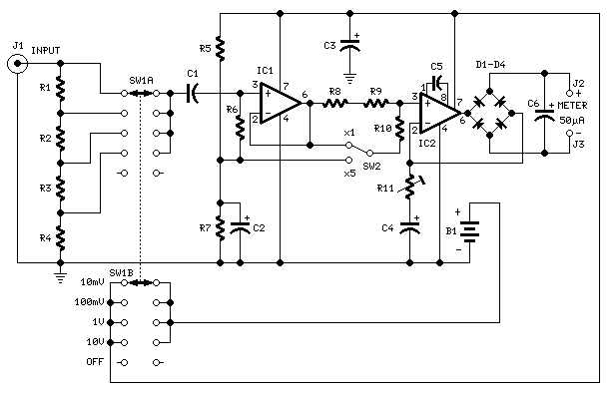
Parts:
R1_____909K 1/2Watt 1% Metal Oxide Resistor
R2______90K9 1/2Watt 1% Metal Oxide Resistor
R3_______9K09 1/2Watt 1% Metal Oxide Resistor
R4_______1K01 1/2Watt 1% Metal Oxide Resistor
R5_____100K 1/4W Resistor
R6_______2M2 1/4W Resistor
R7______82K 1/4W Resistor
R8______12K 1/4W Resistor
R9_______1K2 1/4W Resistor
R10______3K3 1/4W Resistor
R11____200R 1/2W Trimmer Cermet

C1_____330nF 63V Polyester Capacitor
C2,C3__100΅F 25V Electrolytic Capacitor
C4_____220΅F 25V Electrolytic Capacitor
C5______33pF 63V Polystyrene Capacitor
C6_______2΅2 63V Electrolytic Capacitor

D1-D4___1N4148 75V 150mA Diodes

IC1_____CA3140 Op-amp
IC2_____CA3130 Op-amp

SW1_____2 poles 5 ways rotary switch
SW2_____SPDT switch

J1______RCA audio input socket
J2,J3___4mm. output sockets

B1______9V PP3 Battery

Clip for PP3 Battery
Notes:
- Connect J2 and J3 to an Avo-meter set @ 50΅A range
- Switching SW2 the four input ranges can be multiplied by 5
- Total fsd ranges are: 10mV, 50mV, 100mV, 500mV, 1V, 5V, 10V, 50V
- Set R11 to read 1V in the 1V range, with a sinewave input of 1V @ 1KHz
- Compare the reading with that of another known precision Millivoltmeter or with an oscilloscope
- The oscilloscope reading must be a sinewave of 2.828V peak to peak amplitude
- Frequency response is flat in the 20Hz-20KHz range
- If you have difficulties in finding resistor values for R1, R2, R3 & R4, you can use the following trick:
R1 = 10M + 1M in parallel
R2 = 1M + 100K in parallel
R3 = 100K + 10K in parallel
R4 = 1K2 + 6K8 in parallel
All resistors 1% tolerance

