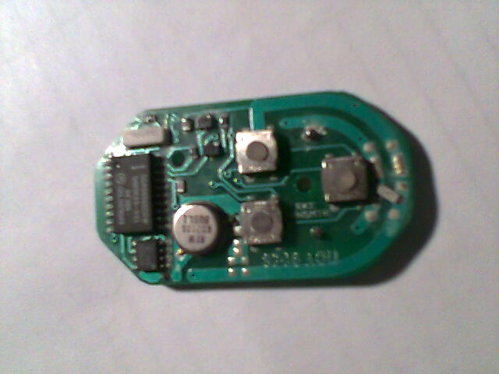
x24 COO
647 I
sc406565cdw
5489r29-001
oe388
CKLDD9649
4,00
RFM
R02101
B08LI

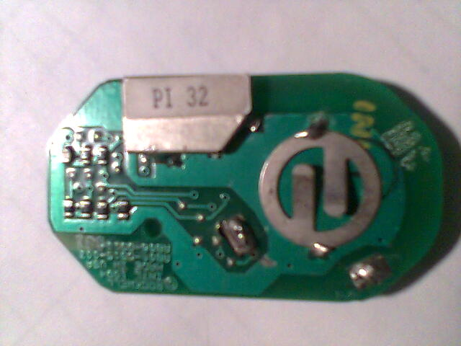
Rockwel
INTL 1994
Madein USA
AB06-D515-003
AB06-D510-081

