ICL7107 / ICL7106 - DIGITAL LED AMMETER (Ampere Meter

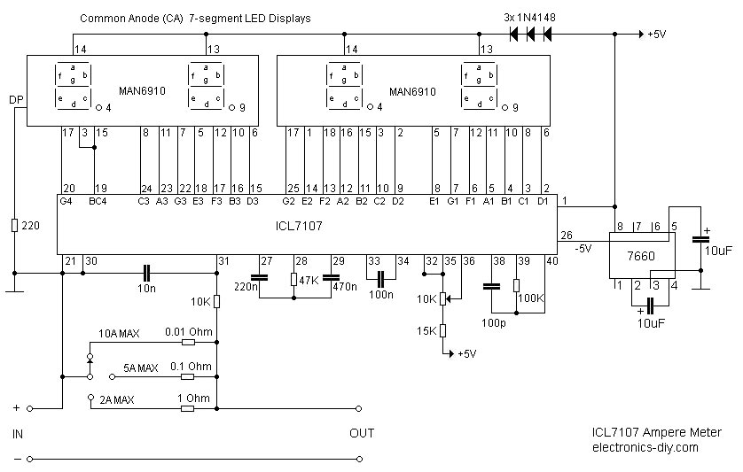

  Part's List:
    0.01 Ohm - 1.5mm / 5cm long copper wire
    0.1 Ohm - 5W Resistor
    1 Ohm - 5W Resistor
    1x - 220 Ohm Resistor
    1x - 10K Resistor
    1x - 15K Resistor
    1x - 47K Resistor
    1x - 100K Resistor
    1x 10K Pot
    1x - 100pF Capacitor
    1x - 10n Capacitor
    1x - 100n Capacitor
    1x - 220n Capacitor
    1x - 470n Capacitor
    2x - 10uF Capacitor
    3x - 1N4148 Diode
    1x - ICL7107 IC
    1x - 7660 IC
    2x - MAN6910 2-digit LED 7-segment Display
  Technical Specifications:
  Supply Voltage: 5V
  Current Consumption: ~ 25mA
  Measurement Accuracy:
  10A - 100mA Resolution - 99.9 A
  5A - 10mA Resolution - 9.99 A
  2A - 1mA Resolution - 1.999 A
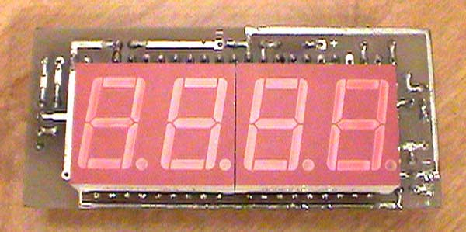
About this Circuit

Ammeter is a great addition to any Laboratory Power Supply as it will measure the current consumption and help you determine if there are any problems with the circuit that you are building or testing. This amper meter is capable of measuring the current consumption up to 10A with selected 100mA, 10mA and 1mA accuracy, and consumes only about 25mA of current. The ammeter is based on single ICL7107 chip and 3.5-digit seven segment LED display. Due to a relatively small number of components that the circuit is using it is possible to fit it on a small 3cm x 7cm printed circuit board.

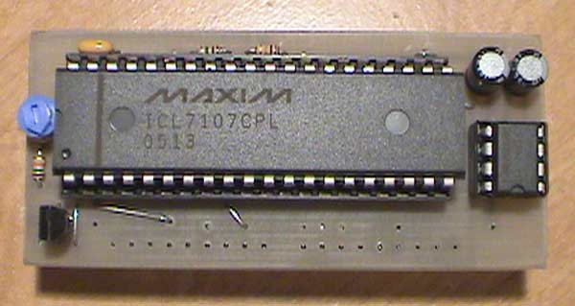
Construction Notes

0.01 Ohm resistor should be made out of 1.5mm thick / 5cm long copper wire. 0.1 Ohm and 1 Ohm resistors should have 5W ratings.
For highest accuracy it is recommended that the ICL7107 ampere meter module should be supplied with its own voltage supply. If measurement of the current of the same supply is needed, ICL7107 ampere meter would have to sample negative not positive voltage supply.
Brightness of the LED displays can be varied by adding or removing 1N4148 small signal diodes that are connected in series. Use two 1N4148 diodes for higher brightness.
Also, the use of 7805 5V voltage regulator is highly recommended to prevent the damage of ICL7107 and 7660 ICs.
Dot on the seven segment LED display can be also moved with addition of a dual switch as shown below.
10A - 100mA Resolution - 99.9 A
5A - 10mA Resolution - 9.99 A
2A - 1mA Resolution - 1.999 A
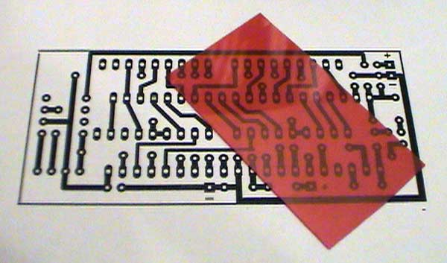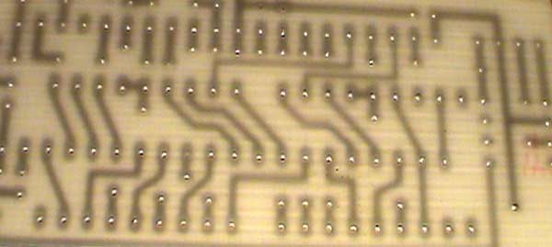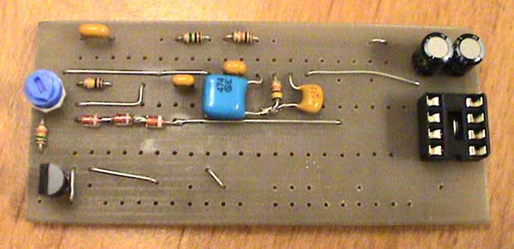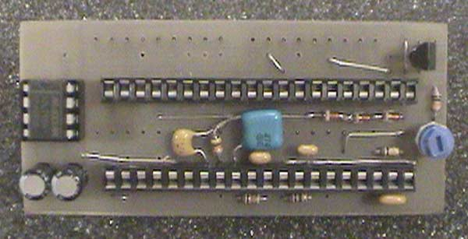
Calibration

Use 10K potentiometer to set the reference voltage between PIN 35 and PIN 36 of the ICL7107 IC to 1V.
Seven Segment LED Display

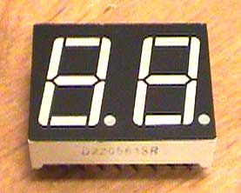 | 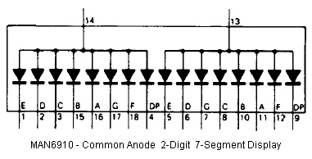
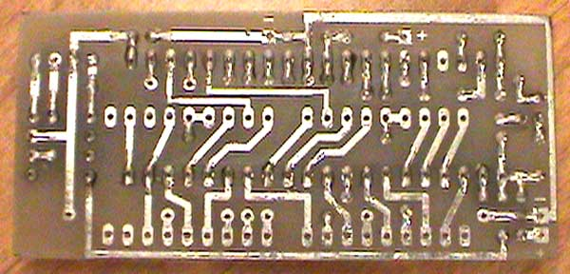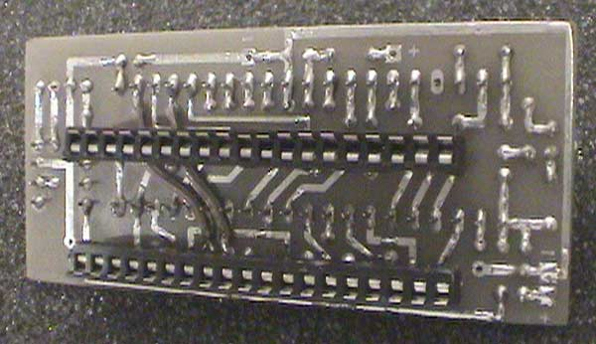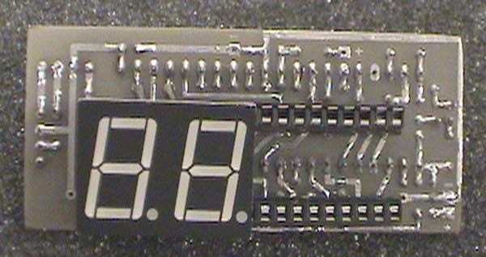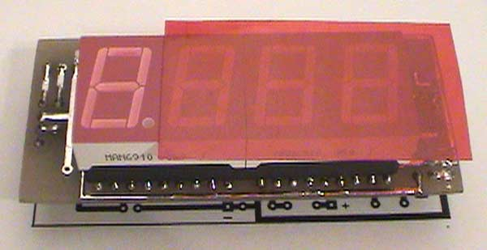

Prototype Images

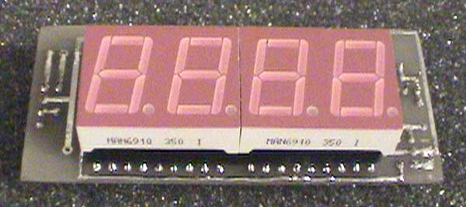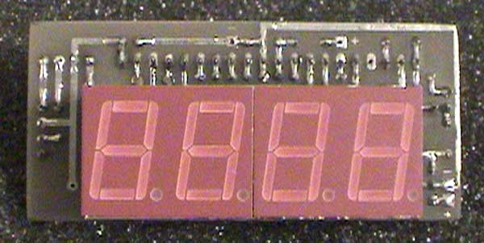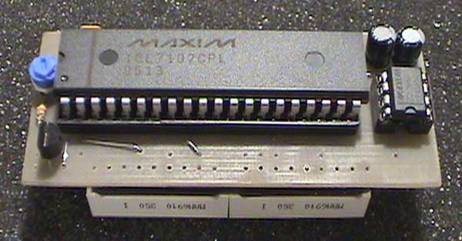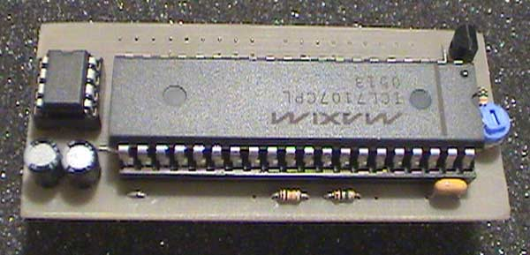
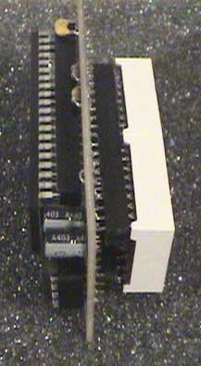 | 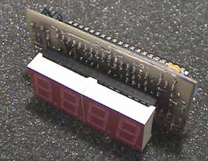 | 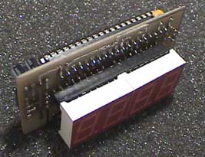
 | 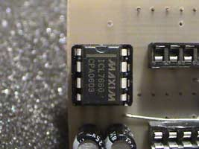 | 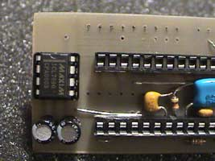
 | 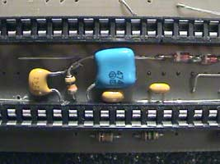 | 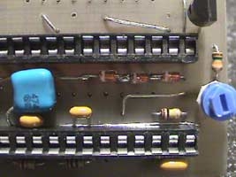

Electronics-DIY.com © 2002-2008. All Rights Reserved.

