Powerful Siren

Simple circuitry - No ICs
12V Battery operation
Circuit diagram:
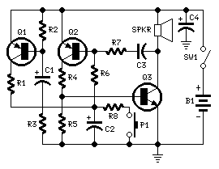
Parts:
R1,R3____________1K 1/4W Resistors
R2,R5___________10K 1/4W Resistors
R4_____________220R 1/4W Resistor
R6_____________220K 1/4W Resistor
R7______________22K 1/4W Resistor
R8_____________100K 1/4W Resistor
C1,C2___________22µF 25V Electrolytic Capacitors
C3______________10nF 63V Polyester or Ceramic Capacitor
C4______________47µF 25V Electrolytic Capacitor
Q1,Q2_________BC557 45V 100mA PNP Transistors
Q3____________BC337 45V 800mA NPN Transistor
SW1___________SPST Toggle or Slide Main Switch (See Notes)
P1____________SPST Pushbutton Operating Switch
SPKR__________8 Ohm Loudspeaker
B1____________12V Battery
Comments:
This circuit was requested by several correspondents. Its purpose was to obtain more power than the siren circuit already available on this website since many years (One-IC two-tones Siren) and to avoid the use of ICs.
A complementary transistor pair (Q2 & Q3) is wired as a high efficiency oscillator, directly driving the loudspeaker.
Q1 ensures a full charge of C2 when power is applied to the circuit. Pressing on P1, C2 gradually discharges through R8: the circuit starts oscillating at a low frequency that increases slowly until a high steady tone is reached and kept indefinitely. When P1 is released, the output tone frequency decreases slowly as C2 is charged to the battery positive voltage through R6 and the Base-Emitter junction of Q2. When C2 is fully charged the circuit stops oscillating, reaching a stand-by status.
Notes:
- A good sized loudspeaker will ensure a better and powerful output tone.
- As stand-by current drawing is zero, SW1 can be omitted and B1 wired directly to the circuit.
- Maximum current drawing at full output is about 200mA.
One-IC two-tones Siren

Double-tone Police sound
Single-tone old ambulance sound
Circuit diagram:
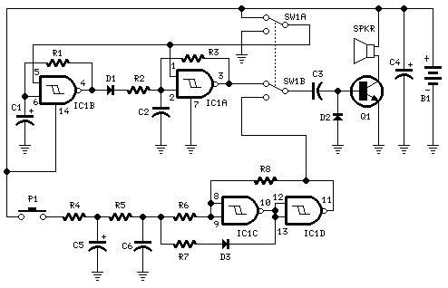
Parts:
R1,R3___470K 1/4W Resistors
R2______680K 1/4W Resistor
R4_______82K 1/4W Resistor
R5______330K 1/4W Resistor
R6_______10K 1/4W Resistor
R7_______33K 1/4W Resistor
R8________3M3 1/4W Resistor
C1,C5_____10µF 25V Electrolytic Capacitors
C2,C6_____10nF 63V Polyester Capacitors
C3_______100nF 63V Polyester Capacitor
C4_______100µF 25V Electrolytic Capacitor
D1-D3___1N4148 75V 150mA Diodes
IC1_____4093 Quad 2 input Schmitt NAND Gate IC
Q1______BC337 45V 800mA NPN Transistor
P1______SPST Pushbutton
SW1_____DPDT Switch
SPKR____8 Ohm Loudspeaker
B1______6V Battery (4 AA 1.5V Cells in series)
Circuit operation:
This circuit is intended for children fun, and can be installed on bicycles, battery powered cars and motorcycles, but also on models and various games and toys. With SW1 positioned as shown in the circuit diagram, the typical dual-tone sound of Police or Fire-brigade cars is generated, by the oscillation of IC1A and IC1B gates. With SW1 set to the other position, the old siren sound increasing in frequency and then slowly decreasing is reproduced, by pushing on P1 that starts oscillation in IC1C and IC1D. The loudspeaker, driven by Q1, should be of reasonable dimensions and well encased, in order to obtain a more realistic and louder output. Tone and period of the sound oscillations can be varied by changing the values of C1, C2, C5, C6 and/or associated resistors. No power switch is required: leave SW1 in the low position (old-type siren) and the circuit consumption will be negligible.

Emergency Siren Simulator
This siren circuit simulates police, fire or other emergency sirens that produce an up and down wail.
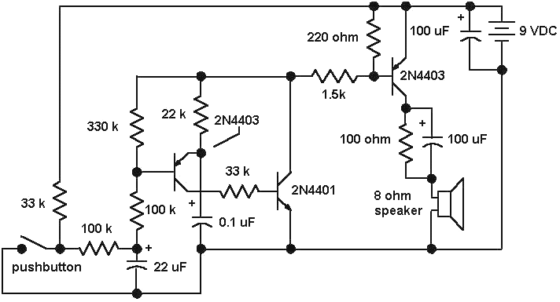
The heart of the circuit is the two transistor flasher with frequency modulation applied to the base of the first transistor. When the pushbutton is depressed, the frequency of oscillation climbs to a peak and when the button is released, the frequency descends due to the rising and falling voltage on the 22 uF capacitor. The rate of change is determined by the capacitor value and the 100k resistor from the pushbutton. The oscillation eventually stops if the button is not depressed and the current consumption drops to a tiny level so no power switch is needed.
The 0.1 uF determines the pitch of the siren: A 0.047uF will give a higher pitch siren and a 0.001 uF will give an ultrasonic (at least for me, anyway) siren from 15 to 30 kHz which might have an interesting effect on the neighborhood dogs! The 33k resistor from the collector of the PNP to the base of the NPN widens the pulse to the speaker giving greater volume.
The flasher circuit drives a PNP transistor which powers the speaker. This transistor may be a small-signal transistor like the 2N4403 in most applications since it will not dissipate much power thanks to the rapid on-and-off switching. The 100 ohm and 100uF capacitor in series with the speaker limit the current to about 60 mA and they may be replaced with a short circuit for a louder siren as long as the transistor can take the increased current. The prototype drew about 120 mA when shorted which is fine for the 2N4403.
Transistor substitutions should be fine - try just about any small-signal transistors but avoid high frequency types so that you do not end up with unwanted RF oscillations.
SIMPLE SIREN
Build your own Simple Siren and learn how it works
This is Project #5 on the PC board in "5-PROJECTS"
To purchase "5 PROJECTS" kit, click HERE.
(you will also need a soldering iron, solder and side-cutters. These are available from your local electronics store)
This project is built on the third section of the PC board, identified by "SIREN" and "Project 5." You will notice the similarity between this circuit and the LED FLASHER circuit from project 2. The only differences are the LED has been removed and the 22R resistor has
been replaced by a mini speaker.
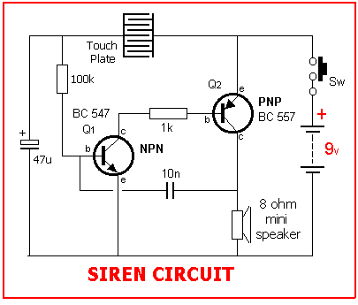
The 10u has also been replaced with a smaller value of capacitance (10n) and this makes the circuit operate at a much higher frequency. The result is a tone from the speaker. (If you connected the speaker to the LED Flasher circuit you would get a "click - click - click"
at 2 clicks per second.
This SIMPLE SIREN circuit uses components we have covered in the front of this book and up to now you have seen how a varying current on the base of the first transistor affects the flash rate of the circuit. Now you will HEAR how the varying current alters the frequency at
which the circuit operates.
PARTS LIST
1 - 1k resistor (brown-black-red-gold)
1 - 100k resistor (brown-black-yellow-gold)
1 - 10n greencap or ceramic
1 - 47u 16v electrolytic
1 - BC 547 NPN transistor
1 - BC 557 PNP transistor
1 - 8R speaker
1 - touch plate - (from project 2)
1 - 20cm hook-up wire for speaker
1 - "5-PROJECTS" PC Board
HOW THE CIRCUIT WORKS
There are many ways to explain how a circuit works and we have presented three different approaches in this course - the voltage approach, the current approach and the resistance approach. Sometimes we have combined all three.
In this final project we will explain how the circuit works using the resistance approach. We start with the touch plate. When the touch plate is touched, the 47u electrolytic gradually charges via the resistance of the plate. In the notes we have explained how
the touch plate works, with its resistance varying according to the pressure of your finger.
The base of Q1 sees the voltage on the electrolytic and when it is about .6v, the transistor starts to turn on.
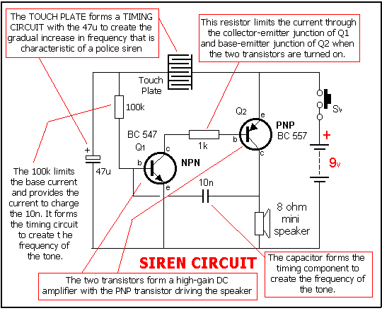
Since Q1 is directly coupled to the second transistor, Q2 turns on too. When Q2 turns on, the resistance between its collector and emitter reduces and allows current to flow. This causes current to flow in the voice coil of the speaker and pulls the cone towards the magnet.
This is the first half of the cycle for the speaker.
Also connected to the collector of the PNP transistor is one end of a 10n capacitor and when one lead of the capacitor rises, the other side rises too. (This is because it is uncharged at the moment). This has the effect of turning on both Q1 and Q2 even harder. This action runs around the circuit until both transistors are turned on fully.
At this point the 10n capacitor begins to charge via the base-emitter junction of Q1 and the collector-emitter junction of Q2. When the capacitor becomes nearly charged, the charging current reduces and it cannot keep Q1 turned on as much and it begins to turn off slightly.
This begins to turn off Q2 and the voltage on the collector of Q2 falls. The 10n capacitor is connected to this and both ends begin to fall and turn off Q1. This action turns both transistors off and the voltage on the base of Q1 is below the negative rail (as explained in Project 2).
Current through the voice coil of the speaker ceases and the cone is released. This completes the cycle for the speaker and it's the action of pulling the cone towards the magnet and releasing it that produces the tone.
The charge on the capacitor is now cancelled by the current from the 100k resistor and it begins to charge in the opposite direction so that the voltage on the base of Q1 rises to .6v. At this point the NPN transistor turns on again and the cycle repeats.
If the touch plate is kept touched, the tone from the circuit gradually rises as the time taken to charge the capacitor at the end of the cycle will be shortened. This is due to a higher voltage being present on the electrolytic and thus a higher current will flow through the
100k resistor to charge the capacitor faster.
Most of the explanations of how the circuits work have opened up more questions than they answered. This is only a commencement book and future books will elaborate on the operation of the circuits in more detail. Even if you have only learnt the resistor colour code and got the projects to work, you will have achieved all this book has intended to get across.
Furthermore, if you like what you have learnt, electronics will be buzz and a very rewarding hobby. Look out for the next books in the series.
ASSEMBLY
All the components fit on the section of the PC board marked "SIREN." The two resistors lay flat on the board and the other components are pushed up until they are about 3mm (3/16") from the board. Use the layout diagram on this page to see where they go and how they fit. Don't forget to hold each part as you solder it to make sure it doesn't get too hot.
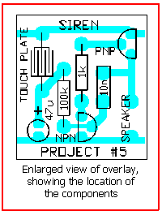
Now for the assembly.
Collect the parts and lay them on the work bench.
You are now ready to start. Mark off each step as you do it.
( ) Bend the leads of the 1k resistor to 90° and push them through the holes identified by the 1k symbol on the board and hold the resistor while soldering it. Cut the ends of the wires with a sharp pair of side cutters making sure you do not cut any of the solder
joint, as this may damage it.
( ) Repeat with the 100k resistor.
( ) Fit the 10n capacitor by pushing the leads through the holes until the body of the capacitor is almost touching the board. Solder the leads quickly so that the component does not get too hot. Cut off the leads neatly.
( ) Fit the 47u electrolytic with the negative lead close to the edge of the board and the positive lead down the hole marked with a "+."
( ) Fit the PNP transistor at the position marked on the board with a "D" symbol, making sure the leads are correct for the transistor you are fitting.
( ) Fit the NPN transistor in the same way.
( ) Connect the touch plate to the holes marked on the board via the two wires attached to it, (you may have to remove it from the other section of the board.)
( ) Fit the speaker wires to the speaker and solder the other ends to the board.
The project is now complete.
Slide the power switch on and the touch the touch plate. After a short while the siren will start up. Keep your finger on the touch plate and the tone will increase. You can regulate the tone by pressing lightly or with more force.
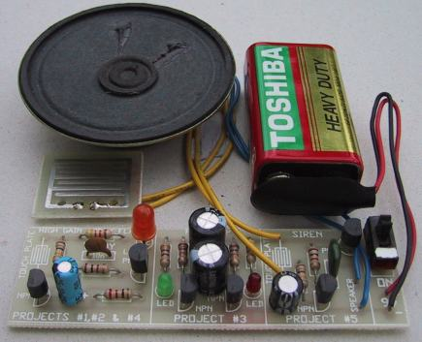
The Siren components fitted to the board.
Touch the Touch-Plate to increase the Siren tone
release to decrease tone.
IF THE CIRCUIT DOESN'T WORK
If the circuit doesn't work, you should go over the construction notes again, making sure you have not left anything off the board. Look at the solder side of the board and make sure no joints have been left unsoldered.
If the other projects are flashing when the power is switched on, the battery will be ok. This circuit will work down to a voltage of 3-4v, so it is not voltage critical.
Look at the speaker to make sure the leads are soldered correctly. The other major cause of a mistake is the transistors. Make sure they are the correct types for both the NPN and PNP positions and make sure they have been fitted correctly.
Get someone else to check this for you as it is difficult to check your own work.
If you have held the transistors while soldering, they will not be damaged, but if you had to let go, they could be damaged.
Buy two more as "spare parts" and fit them to the board.
In later pages we will show how to test the circuit using a multimeter and other test equipment but we have not covered these yet and the only thing you can do is visually inspect the board for correct parts placement and make sure the soldering is neat.
If you have made a mess of your PC board, it would be a cheap price to buy another board (or book), get another kit of components and start again.
This time you will make a much neater job and learn a lot in the process.
You really have to feel you have been successful with this e-book before you should go on to the next in the series.
WHAT HAVE YOU LEARNT?
These are the areas we have covered in this e-book: Tick those you have understood:
( ) Recognising components such as transistors, resistors, capacitors.
( ) Placing components correctly on a Printed circuit board.
( ) Soldering components neatly to a PC board.
( ) Holding components while soldering so that they do not get too hot.
( ) Understanding the concept of resistance - high resistance and low resistance.
( ) Understanding the concept that a capacitor stores energy - it "charges up."
( ) Understanding a speaker produces a tone by current flowing through
the voice coil then ceasing to flow and repeating the process to produce a tone.
( ) Understanding a LED produces coloured light when current flows through the special type of crystal it is made of. The colours are: red, green, yellow, orange and blue.
( ) Understanding a transistor is an amplifying device with the
base as the input and the collector as the output.
( ) Understanding current flows through a circuit when it is switched on. In the siren circuit for example, there are a number of different current paths and a different value of current flows through each path.
You don't have to FULLY UNDERSTAND any of the concepts, just be aware that they exist and be prepared for further study in future pages.
THE END
This completes the 5 projects.
There is a lot to be learned from the circuits in this project as they are often used in our other projects.
You can experiment with the circuits to create different effects. By placing a different value resistor across those on the board, you will be able to see the effect of lowering the resistance.
Some of the capacitors can also be changed and the effect will be quite noticeable. This is a very good way to find out the effect of various components on the operation of the circuit.
The only page remaining is the TEST PAGE. See how much you have learned by taking the test . . .
February 2001 Project : Assortment of Siren Circuits
This month I am making 3 different types of siren circuits based on the 555 timer. The first circuit simulates the siren of a British police car. It uses two 555 timers in the circuit. The 555 on the right is wired as an alarm tone generator and the second 555 timer on the left is a 1 Hz astable multivibrater. The output of the left timer is to frequency modulate the right timer. This causes the right timers frequency to alternate between 440Hz and 550Hz at a 1 Hz cyclic rate. The transistor is used to help strengthen the signal to the speaker.
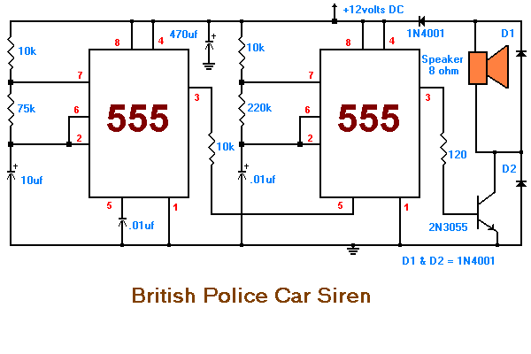
Back to Projects Page
The second circuit simulates the siren of an American police car. It uses two 555 timers in the circuit. The 555 on the right is wired as an alarm tone generator and the second 555 timer on the left is wired as a low frequency astable timer which generates a ramp waveform of about 6 seconds that is buffered by the transistor and again used to frequency modulate the tone generator. The transistor is used to help strengthen the signal to the speaker.
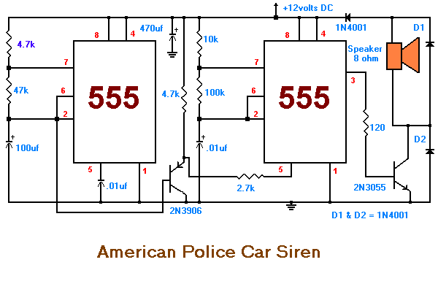
Back to Projects Page
The third circuit simulates the "Red Alert" siren from the TV show Star Trek. It uses two 555 timers in the circuit. The 555 on the right is wired as an alarm tone generator and the second 555 timer on the left is wired as a 1.5 second non-symmetrical astable that generates a fast rising but slow falling saw tooth waveform. This waveform is buffered by the transistor and used to frequency modulate the tone generator and making its frequency rise slowly during the falling parts of the saw tooth but collapse rapidly during the rising part of the saw tooth. The output starts as a low frequency, rises for 1.15 seconds to a high tone, ceases for .35 seconds and then repeats the cycle.
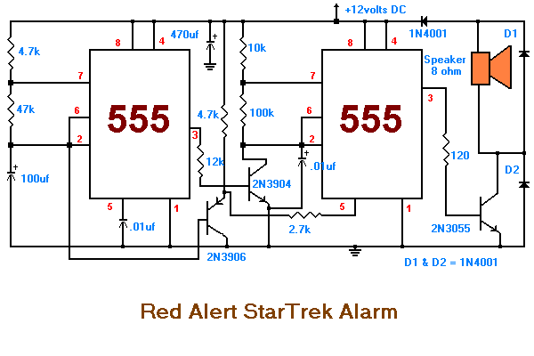
Electronic Siren

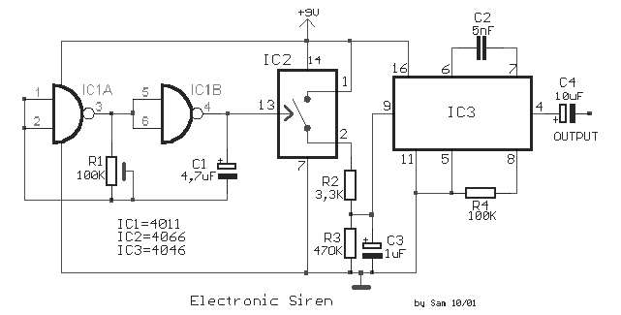

With this circuit we can create a altered sound of siren. The oscillator IC1a-b is constituted by two gates NAND, oscillating in very low frequency. This oscillation drive the IC2, that is a electronic switch, which opens and closes in the rythm of oscillation. When closes the switch then the voltage of supply charge the capacitor C3 through the resistance R2. When switch IC2 opens, the C3 discharge through the R3. The voltage with which is charge the C3, regulates the VCO of IC3, that is PLL, so that we have in the exit his one altered sound. You can experiment with the prices of resistances and capacitors in order to you change the sound of siren. The R1, C1 check the time of operation, the R4, C2 check the frequency of produced sound and the R3, C3 check the change of sound.

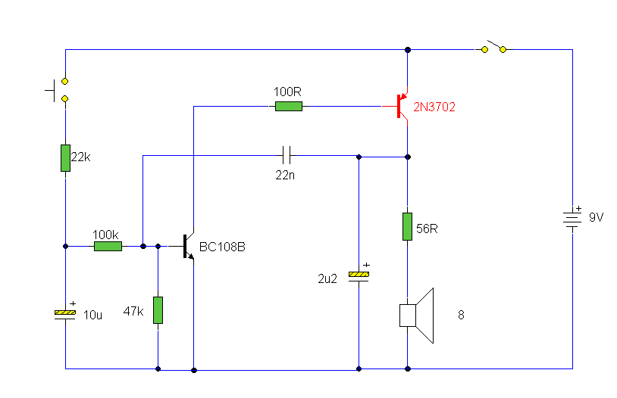

Notes:
The sound produced imitates the rise and fall of an American police siren. When first switched on the 10u capacitors is discharged and both transistors are off. When the push button switch is pressed to 10u capacitor will charge via the 22k resistor. This voltage is applied to the base of the BC108B which will turn on slowly. When the switch is released the capacitor will discharge via the 100k and 47k base resistors and the transistor will slowly turn off. The change in voltage alters the frequency of the siren. The oscillator action is more difficult to work out. As the BC108B transistor switches on its collector voltage falls and so the 2N3702 transistor is switched on. This happens very quickly ( less than 1us). The 22n capacitor will charge very quickly as well. As this capacitor is connected between the collector of the 2N3702 and the base of the BC108B, it soon reaches almost full supply voltage. The charging current for the capacitor is then much reduced and the collector emitter voltage of the 2N3072 is therefore increased; the collector potential will fall. This change in voltage is passed through the 22n capacitor to the base of the BC108B causing it to come out of saturation slightly. As this happens its collector voltage will rise and turn off the 2N3072 transistor more. This continues until both transistors are off. The 22n capacitor will then discharge via the 100k, 22k resistor, the closed push button switch, 9V battery, the speaker and 56 ohm resistor. The discharge time takes around 5-6msec. As soon as the 22n capacitor is discharged, the BC108B transistor will switch on again and the cycle repeats. The difference in voltage at the collector of the BC108B (caused by the charging 10u capacitor) causes the tone of the siren to change. As the 10u capacitor is charged, the tone of the siren will rise, and as it is discharged, it will fall. A 64 ohm loudspeaker may be used in place of the 8 ohm and 56 resistor, and the values of components may be altered to produce different sound effects.

Simple 6-input alarm circuit
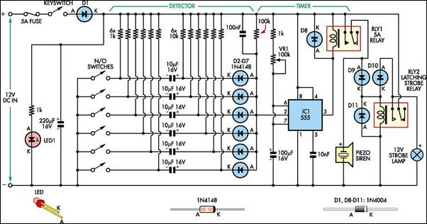
This simple alarm circuit was designed for use in a combined garage and rumpus room. It can be assembled on Veroboard and uses just one IC plus a handful of cheap components.
The circuit is based on a straightforward 555 timer circuit (IC1). This is wired as a monostable and sets the siren period which is adjustable up to about three minutes using potentiometer VR1.
In operation, IC1's pin 2 input monitors the detector circuit for negative-going signals. When a switch is closed, a brief negative-going pulse is applied to pin 2 via a 10μF capacitor and its corresponding series diode (D2-D7). This triggers IC1 which switches its pin 3 output high and switches off relay RLY1 (ie, RLY1 is normally on).
As a result, the piezo siren sounds for the duration of the monostable period. In addition, relay RLY2 is turned on via diode D9 and latches on via D10. This means that the strobe light (which is wired to the normally open contact) will continue to flash until the alarm is switched off (via the keyswitch).
At the end of the monostable period, RLY1 turns off and this turns off the piezo siren. The circuit can then be retriggered by any further trigger inputs from the switches.
A variety of detectors with normally open contacts can be used for the switches, including reed switches, pressure mats, IR detectors and glass breakage detectors. All switches must be open before the alarm is switched on.

Wailing Alarm Siren
by Tony van Roon
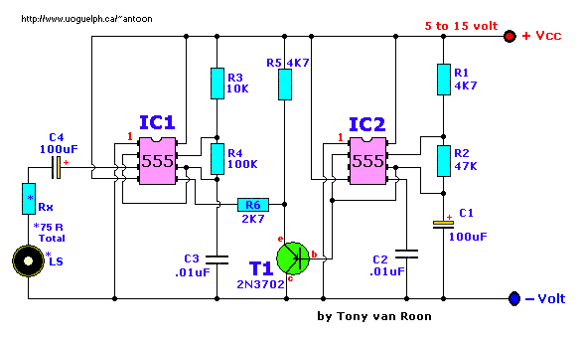

Parts List:
R1,R5 = 4.7K C1,C4 = 100uF/25V, electrolytic
R2 = 47K C2,C3 = 0.01uF (10nF), ceramic
R3 = 10K T1 = 2N3702 (NTE159, TUP, etc.)
R4 = 100K IC1,IC2 = LM555, NE555, µA555
Rx = *Notes LS = Loudspeaker. *Notes
Notes:
This circuit provides a warbling sound to any alarm circuit. IC2 is wired as a low frequency astable with a cycle period of about 6 seconds. The slowly varying ramp waveform at C1 is fed to pnp emitter follower T1, and is then used to frequency modulate alarm generator IC1 via R6. IC1 has a natural center frequency of about 800Hz. Circuit action is such that the alarm output signal starts at a low frequency, rises for 3 seconds to a high frequency, then falls over 3 seconds to a low frequency again, and so on.
*The Loudspeaker LS and the resistor marked "Rx" should be together 75 ohms. If you have a standard 8-ohm speaker then Rx is 67 ohms. The nearest value is 68 ohms. So for a 8 ohm loudspeaker Rx is 68 ohms. For a 4 ohm loudspeaker Rx is 71 ohms, for a 25 ohm loudspeaker Rx is 50 ohms, etc, etc.
BUT, the Rx value is not very critical. It is just there as some sort of volume control. Experiment with it. C2 and C3 are 0.01uF (10nF) and a simple ceramic type will do the job. I tested the circuit at 9, 12, and 15 volt. My choice would be 9volt alkaline for battery operation or 12volt for use with a small powersupply. Output pin 3 of IC2 is NOT connected; just in case you are wondering... :-) In my prototype I used LM555 timers.

