Installing Oracle's Java on Raspberry Pi

(Java JRE)
Submitted by Klemen on Wed, 02/13/2013 - 06:53
A lot of people is asking me if it's possible to have Java on Pi. My answer is YES. To make dreams of a lot geek true, I made this article. You get Java and even compiler if you carefuly follow my instructions.
- 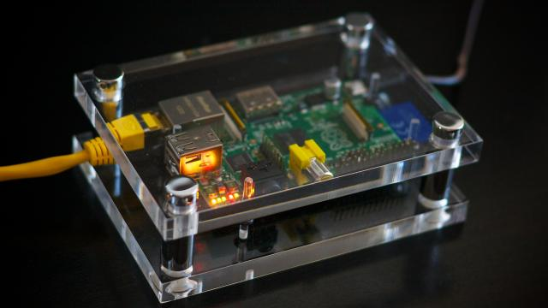
A lot of people is asking me if it's possible to have Java on Pi. My answer is YES. To make dreams of a lot geek true, I made this article. You get Java and even compiler if you carefuly follow my instructions.
You need to have Soft Float distribution of Debian for Raspberry Pi to get Java to work. Then just follow these instructions and Java should work.
Download Java LinuxARM JDK7 SE distribution from this link to your PC. Then, you need to enable SSH on your Pi. Type
Innen töltöttem le a Javat zippelve: http://www.oracle.com/technetwork/java/javase/downloads/index.html
(A 7u60 Linux/arm headless-t raktam fel, 31 MB)
Majd WinScp-vel át a Pi-re a home/pi mappába
Move it into home/pifolder.
Then we need to make folder in wich should we put our files:
sudo mkdir -p -v /opt/java
Then we unzip Java files using the following command:
tar xvzf ~/(Name of your Java package file).gz
Then we move Java files into /opt/java:
sudo mv -v ~/jdk1.7.0_06 /opt/java
Then we need to tell that new JVM has been installed on Raspberry Pi:
sudo update-alternatives --install "/usr/bin/java" "java" "/opt/java/jdk1.7.0_06/bin/java" 1
sudo update-alternatives --set java /opt/java/jdk1.7.0_06/bin/java
Then, this command should work and give this result:
java -version
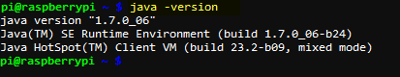
Majd ezután még telepíteni kell az IcedTea plugint a böngészőnek:
Ez alapján:
Hi all
Can anyone suggest a reasonable way of enabling java applets on a typical raspbian installation? I'm happy to either update Midori or install a different browser if needed.
you get java applet support by installing the IcedTea-web java browser plugin that work in combination with OpenJDK.
http://icedtea.classpath.org/wiki/IcedTea-Web
to install icedtea-web run:

sudo apt-get update
sudo apt-get install icedtea-plugin
És a Midori megnyitja a PLC Java Appletet.
Itt van egy Java tesztoldal: http://www.w3.org/2000/07/8378/object/java/clock

