I downloaded NQ-Designer 1.2 I set COM1 in NQ5 to regular hostlink and downloaded to NQ5. I uploaded to check if parameters are OK:
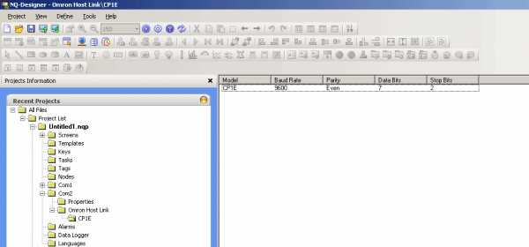
I set CP1E as below, after uploading it looks like:
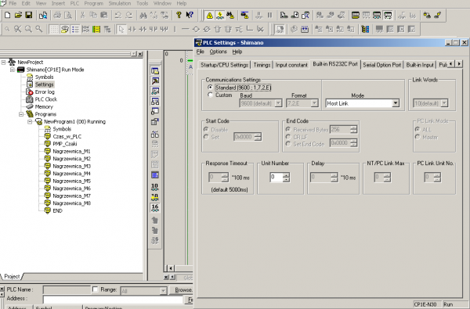
I prepared cable
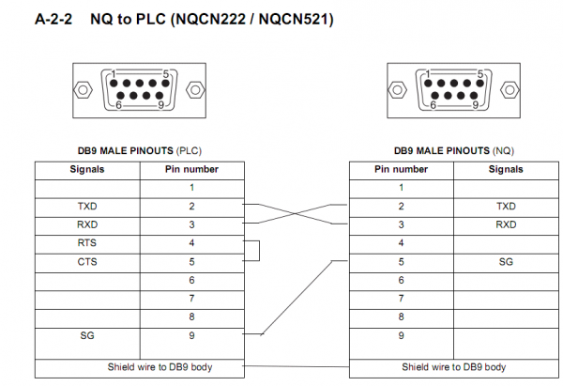
and NO CONNECTION
It should be so simple. I tried with COM2 the same - no connection ; I tested ports in NQ without loopback - looks OK
The problem is that I do not see flashing COMM LED on RS232 Built-in port in CP1E - just from time to time but when I start NQ5 every time I have - check power and cable - no connection.
What I can do more?...
Thanks for clue

I think the NQ3 looks for the Hostlink address to be 1 by default.
Try changing the address on the settings dialog box to 1.
Pp

Where I can find this address?
When I open tab for COM1 setup in my NQ5 I have only:
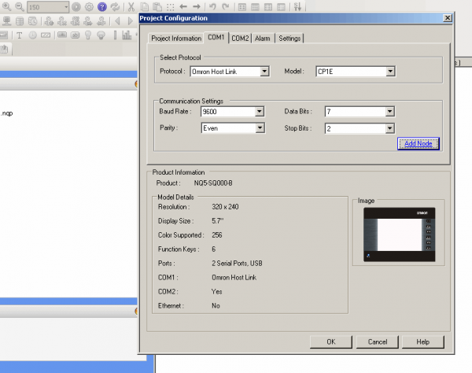
In settings for CP1E I can change only unit number to 1, but for sure I have set there 0 - built-in port is there

Here...
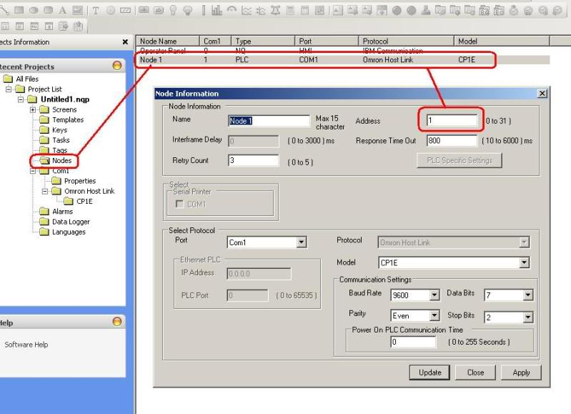
Pp
0
Right now I do not have cover on DB9 plugs and I am sure the DB9 with bridge 4&5 is in PLC rs232 port.
I double checked wire continuity and cable is correct.
I disconnected USB cables from NQ and PLC but still during NQ powering up - I have info no connection "check power and cable"
Wire shields is connected to both DB9 plugs - I tried with just one connection to DB9 plug - no success
My CP1E needs battery - soon I will have - maybe it is the reason - quite stupid idea, but maybe.
I am completely stunned.
No. You don't understand. The unit number is set to 0 in the plc (your first post). Change both to 0 or 1.
Pp

Thank you - Pp - finally it started working - UNIT NUMBER in <RS232 port> tab for PLC has to be the same as an ADDRESS in <node> tab for NQ

