Plants Watering Watcher - Version II

A flashing LED signals the necessity to water a plant

Very low current consumption - 3V powered circuit

Circuit diagram:
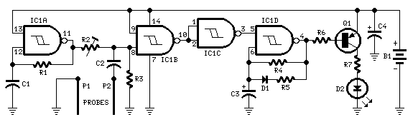

Parts:
R1,R4________470K 1/4W Resistors
R2____________47K 1/2W Trimmer Cermet or Carbon
R3___________100K 1/4W Resistor
R5_____________3K3 1/4W Resistor
R6____________15K 1/4W Resistor
R7___________100R 1/4W Resistor

C1_____________1nF 63V Polyester Capacitor
C2___________330nF 63V Polyester Capacitor
C3,C4_________10µF 25V Electrolytic Capacitors

D1__________1N4148 75V 150mA Diode
D2_____________5mm. Red LED

IC1___________4093 Quad 2 input Schmitt NAND Gate IC

Q1___________BC557 45V 100mA PNP Transistor

P1,P2_______Probes (See Notes)

B1______________3V Battery (2xAA, N or AAA 1.5V Cells in series)

