Power amplifier 65W with HEXFET

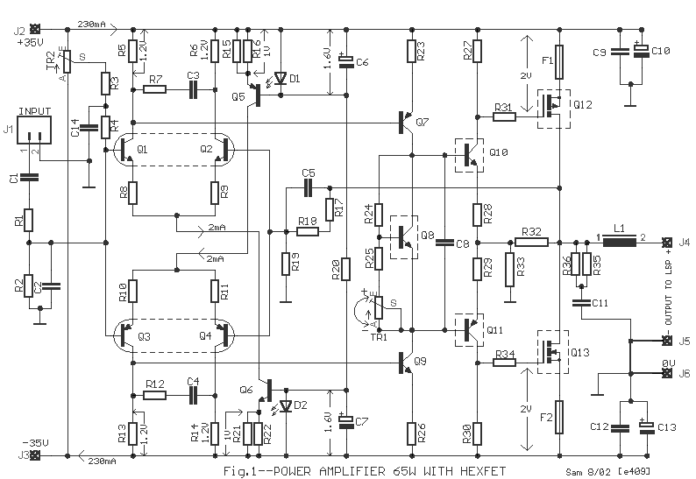

A medium power amplifier that is characterized by a lot of good sound quality, but simultaneously is very simple in the construction. Him uses, enough time in my active loudspeakers. In his output stage exist the very good FET transistors, technology HEXFET, transistor which are controlled by voltage and no by current as the classically bipolar transistors. The circuit has symmetrical designing, resolving thus the harmonic distortion problem. All the transistors that are used in the circuit are simple and they exist in big clearings in the market. The pairs of differential amplifiers Q1-2 and Q3-4 should be matched between them and near the one in the other. Thus you can buy enough transistors of types BC550C and BC560C, and with a multimeter you match between them creating pairs with same characteristics, ensuring thus uniform behavior in the temperature changes etc. Networks RC from the R7/C3 and R12/C4 decrease the bandwidth of differential amplifiers and power amplifier in the 6.5MHZ. Resistors R8-9-10-11 function as local feedback in the differential amplifiers improving the linearity. The differential amplifiers are supplied with constant current from him current sources Q5 and Q6. The bias of current sources becomes from the combination of diodes LED D1, D2 and R20. This becomes because the combination transistor/LED ensures big thermic stability, for this reason should they are in very near distance [1]. With the TR1 trimmer we regulate the bias current of output power stage. For this reason Q8 should find itself on the heatsink so that it ensures thermic stability in the bias, so that it does not change with the temperature changes. The resistors R32-33 shape a local feedback bronchus in the output stage, because this functions as voltage amplifier. With the TR1, R3-4, C14 we regulate the amplifier output DC offset voltage, near in the zero. The transistors Q8-10-11-12-13, [Fig.1] should are placed on heatsink, adding between the transistors and the heatsink of good quality leaves mica and ointment. Inductor L1 is constituted by 6 coils of insulated cupreous wire of diameter 1.5mm, with internal inductor diameter of 16mm [2].
Adjustment
Previous to we supply the amplifier with voltage, we regulate the trimmer TR2 in the mid of his way and the trimmer TR1 in biggest resistance. We connect a multimeter in output pin J4 (measurement range 200mV DC), we give voltage in the amplifier and with the TR2 we regulate so that we take DC voltage in the output as possible near in the zero. We remove the supply and connect a multimeter (range 1A or 2A) in line with one from the supply cables. We again give supply in the amplifier and with the TR1 regulate late the current, so that we take clue roughly 330mA. We leave the amplifier to work for 10 min., without audio signal in his input. Afterwards the 10-min. usually the current stabilized in 230mA roughly. If it needs we adjust late so that we take clue near in 230mA. We again check the amplifier DC offset [J4] output, for changes DC and if it needs we regulate again with the TR2. [Elektor12/93].

R1-15-16-21-22-17-18=1K | R33=68R 5W | Q1-2=BC550C [matched]
R2=47K | R35-36=6R8 1W | Q3-4=BC560C [matched]
R3-4=10M | TR1=1K trimmer | Q5=BC560C
R5-6-13-14=1K2 | TR2=1M trimmer | Q6=BC550C
R7-12=47R | C1=2.2uF 63-100V MKT | Q7-11=BD140
R8-9-10-11=22R | C2=1nF 100V MKT | Q8-9-10=BD139
R19=82R | C3-4=2.7nF 100V MKT | Q12=IRF9540
R20=22K | C5=330pF ceramic or mylar | Q13=IRF540
R23-26=56R | C6-7=100uF 16V | F1-2=Fuse 2.5A Fast
R24=2K2 | C8=1uF 100V MKT | L1=see text [2]
R25=560R | C9-11-12=100nF 100V MKT | J1= 2pin connector 2.54mm step
R27-30=150R | C10-13=470uF 63V
R28-29-31-34=15R | C14=33nF 100V MKT | Q8-10-11-12-13 on Heatsink
R32=150R 5W | D1-2=LED RED 3mm [see text] [1] | All the resistors is 1/4W 1% except quote differently

SPECIFICATIONS
POWER RATING at 1KHZ with 0.1% THD | 63W/ 8ohm, 105W /4ohm
IMD | <0.008%
THD at 60W into 8 ohm and 1 KHZ | <0.005%
THD at 60W into 8 ohm and 20 HZ....20 KHZ | <0.05%
FREQUENCE RESPONSE [at 35W/8ohm, +0...-3dB] | 1.5 HZ.....125 KHZ
INPUT SENSITIVITY | 1Vrms
ΙΝPUT IMPEDANCE | 48K
SLOW RATE with input filter | 20V/uS
SIGNAL TO NOISE RATIO [at 1W/8ohm] | >99dBA
DAMPING FACTOR at 8ohm [20HZ...20KHZ] | >160

Power Supply

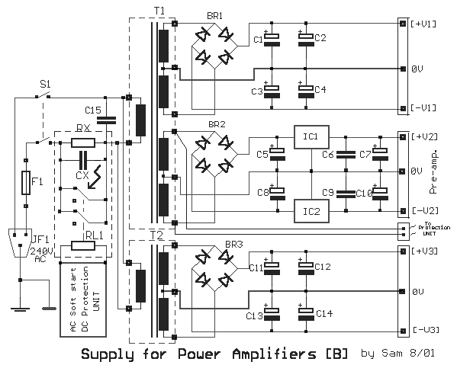

The power supply circuit, is a classic circuit. Proposed power supply for amplifier 65W HEXFET is what appears in the above form. It has separated supply for the various supply stages, for power output stage, for control stage, for preamplifier supply and for protection stage. Whoever wants it can suppress department or add a power supply for each channel, separating completely the channels between them. For whoever it does not use the preamplifier circuit and protection can suppress proportional coil. In his input exist the soft starting circuit, that combine with the delay circuit and protection loudspeakers from DC.
+V1=+35V -V1=-35V
+V2=+12V -V2=-12V
+V3=+35V -V3=-35V
- DC Protection / Time Delay for Loudspeaker

T1=2X25Vac 160VA //2X15Vac 20VA | C5-8=1000uF 25V | IC2=7912 Regulator
T2=2X25Vac 160VA | C6-9=100nF 100V MKT | F1=FUSE 2A slow block
BR1-3=200V 35A Bridge Rectifier | C7-10=10uF 25V | S1=2X2 switch 10A
BR2=4 X 1N4002 | C15=33nF 630V Class X2 | JF1=3 pole male plug
C1...4-11...14=10000uF 63V | IC1=7812 Regulator

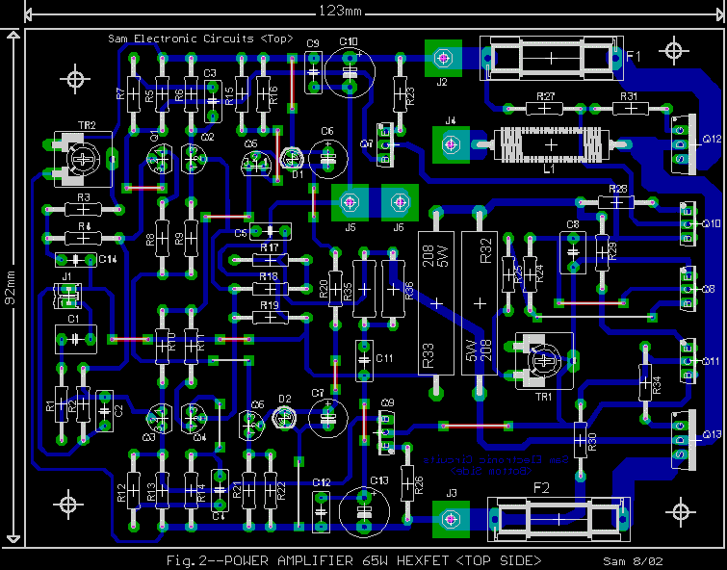
Fig.2--POWER AMP. 65W HEXFET [TOP SIDE] PCB
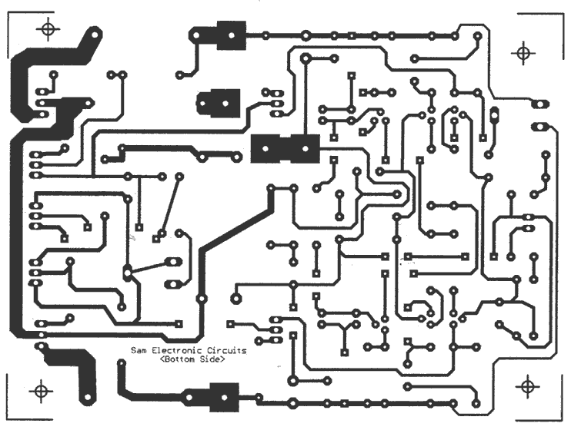
Fig.3--POWER AMP. 65W HEXFET [Bottom side] PCB

Sam Electronic Circuits 8/02

[ Home ] [ My Database ] [My Guestbook ]

