Simple circuitry - No ICs
12V Battery operation
Circuit diagram:
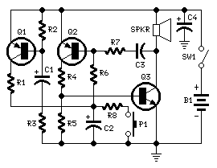
Parts:
R1,R3____________1K 1/4W Resistors
R2,R5___________10K 1/4W Resistors
R4_____________220R 1/4W Resistor
R6_____________220K 1/4W Resistor
R7______________22K 1/4W Resistor
R8_____________100K 1/4W Resistor
C1,C2___________22µF 25V Electrolytic Capacitors
C3______________10nF 63V Polyester or Ceramic Capacitor
C4______________47µF 25V Electrolytic Capacitor
Q1,Q2_________BC557 45V 100mA PNP Transistors
Q3____________BC337 45V 800mA NPN Transistor
SW1___________SPST Toggle or Slide Main Switch (See Notes)
P1____________SPST Pushbutton Operating Switch
SPKR__________8 Ohm Loudspeaker
B1____________12V Battery

