1,500W / 4 Ohms Power Amplifier
Rod Elliott (ESP)

Introduction
This project is mainly in answer to those for whom no amount of power is enough. I have lost count of the number of times people have asked if it's alright to increase the supply voltage on every circuit published, and in general the answer is no - it's not alright. Every design on this site is optimised for the stated power. There is always some flexibility, but you must be very careful to make sure that transistor safe operating area (SOA) is not exceeded. There is also a maximum voltage for any semiconductor, and devices must be selected to ensure they are used within their ratings.
While (lateral) MOSFETs offer some real advantages, they are relatively expensive, and difficult to obtain with voltage ratings above 200V. Vertical MOSFETs (e.g. HEXFETs and the like) are a possibility, but suffer gross non-linearity at very low currents. Therefore, a relatively high quiescent current is needed, and this makes heat removal that much more difficult. There are other issues as well, but a discussion of them is outside the scope of this article.
WARNING
This project describes an amplifier, power supply and tests procedures that are all inherently dangerous. Nothing described in this article should even be considered unless you are fully experienced, know exactly what you are doing, and are willing to take full 100% responsibility for what you do. There are aspects of the design that may require analysis, fault-finding and/or modification.
By continuing to read this article and/or commencing work on the project, you provide your implicit agreement that ESP shall be held harmless forany loss or damage, howsoever caused. You accept all risks to life, limb and finances (this will be a very expensive undertaking) that the project may present. ESP accepts that there may be errors and/or omissions in the text and diagrams that follow, and you accept that these become your responsibility should you decide to build the project.
No assistance whatsoever will be provided for this project! If you ask me questions about it, they WILL NOT be answered!
Capable of 2kW peak and a minimum of 1.5kW continuous, it has to be said that this amplifier will blow up any speaker connected to it. Regardless of the claimed power that various drivers can handle, they can't. To put this whole issue into perspective, take the most powerful and robust driver you can (8 ohms), and connect it directly to the 110V mains (I recommend this as a 'thought experiment', rather than actually doing it!). 110V RMS into 8 ohms is 1,500W. How long would you expect the speaker to last? Most will be toast within perhaps 30 seconds or less! A very few will last slightly longer, but none will take that level of abuse for more than a few minutes.
I strongly suggest that you read Power Vs. Efficiency before continuing.
Have a look at the voicecoil of any speaker. Imagine how hot it will get with even 100W of continuous power - feel a 100W light bulb - 100W is enough to make any small mass get very hot indeed, very quickly. 1,500W is an awesome (scary even) amount of power! Look at the size cable needed to carry 20A, then look at the wire size used for the voicecoil. If you don't see a real problem, then I suggest you abandon electronics take up flower arranging as a hobby.
It must be understood that this is a 'brute force' approach, and that much is deliberate. Although it would be possible to use more finesse in the final design (such as using a tracking power supply, or a Class-G multi supply rail approach), these are harder to design, and would require building a prototype to verify performance. Since I have no need at all for this much power, I am not prepared to spend the time and money to build and test something I'll never need.
I know that no speaker I have (or am likely to ever have) can take that much power, and the amp would be a waste of money. Should someone be silly enough to pay me the AU$12,000 I would charge to build a mono version of the amp, then I would happily do so. So, I am confident that it will work as described, but it will almost certainly never be built by me. I hope that my readers share my pragmatism.
Should you (wisely) decide that this amp is as silly as I think it is, then go back to Project 68. The dual board version with ±70V supplies is still capable of destroying many drivers, but there are loudspeakers than can take its output short term. This makes it ideal for subwoofer duty, easily giving over 500W into 4 ohms for transient signals, or 450W continuous (which it can do all day with a fan forced heatsink). This is a proven design, and although not inexpensive, it still represents fairly good value for such a high power amplifier. IMHO there is no point trying for more power, as few drivers can handle more than a couple of hundred Watts without suffering severe power compression.

Description
First, let's look at the requirements to get 1.5kW into 4 ohms. We need 77.5V RMS across the load, but we need to have a bit more, because the supply voltage will collapse under load, and there will always be some voltage lost across the transistors, emitter resistors, etc. The supply voltage needs to be ...
V_{DC} = V_{RMS} * 1.414
V_{DC} = 77.5 * 1.414 = ±109.6V DC
Since we have not allowed for losses yet, we need to allow around 3-5V for the amplifier, and an additional 10V or so to allow for the supply voltage falling when the amp is loaded. The higher the current, the greater the I²R (resistive) losses, so 5V was used in this design. With a transformer rated at 2 x 90V, this gives an unloaded supply of ±130V DC (260V DC total), so the supply has to be treated with extreme care - it is very dangerous indeed. There is an old term used by those who work with high voltages ...
One flash and you're ash !
... and you would do well to remember this. Add on the auxiliary supplies (taking the total to 270V DC), and the supply is capable of killing you several times over, even after it is disconnected from the mains. Even the output signal to the speakers must be treated with care, as 77V is enough to give you a nasty shock.
The final supply voltage will be around ±120V, because even with the biggest transformer and filter capacitors, you will lose voltage. The current demand is also prodigious. With a peak voltage of 110V, the peak supply current is 27.5A into a 4 ohm load. RMS speaker current is just under 20A at full power. Everything you thought you knew about amp building needs to be re-thought. PCB tracks cannot be used for these current levels, because the extra resistance will cause current balancing problems with the power transistors. All wiring needs to be extremely robust, and must absolutely not allow any possibility of contact (it will kill you) or short circuits (which will kill the amp). The supply is capable of vaporising thin wires and PCB tracks.
Because of the issues discussed above, bipolar transistors were selected as most appropriate for the output stage. This was primarily dictated by the supply voltage, which exceeds that allowed for any affordable lateral MOSFET. It is even a challenge for affordable BJTs, but the MJ15004/5 or MJ21193/4 pairs are within ratings, so these are suggested. While I would normally specify a compound pair (also called a Sziklai pair) for the output stage, in this case it is a triple stage, and the Sziklai pair (much as I like it) can be prone to oscillation, primarily on the negative side. This is highly undesirable for an amp with the power of that described here. Despite reservations, the triple Darlington is more appropriate for this application.
Next, we need to look closely at the power dissipation of the devices. Worst case resistive load dissipation occurs when ½ the supply voltage is across both load and transistors. This occurs at a voltage of 65V across the load (worst case), and gives a peak (instantaneous) power in both load and output stage of ...
P = V² / R = 65² / 4 = 1056W
This is only a starting point, because we must have a safety margin. Remember that the peak dissipation into a reactive load with a 45° phase angle is almost double that calculated above, about 1900W. If the transistors can be maintained at 25°C (not likely), that's fine, but we need to add more to allow for elevated temperature. I have elected to use 9 output devices, with a tenth device used as a driver. This maintains worst case peak dissipation at 212W - not much of a safety margin, but it should be ok in practice - in part because the supply voltage will collapse under load. Cooling is vitally important - this amplifier will need a very substantial heatsink, and fan cooling is essential. Fans should cut in at no higher than 35°C.
The MJ15024/5 (or MJ21193/4) devices are TO-3 packages, and are specified for 250W dissipation at 25°C. It is worth noting that the driver in this arrangement will contribute some of the output, but it only reduces the main transistor's peak dissipation by about 5W. TO-3 devices are specified because they have the highest power rating of any general purpose package, because thermal resistance is lower than any flat-pack plastic device.
The MJE340/350 pre-drivers reduce the loading on the VAS (voltage amplification stage) and ensures good linearity with acceptably low dissipation of the VAS transistor (Q4) and its current source (Q6). Even so, with around 12mA through the VAS, dissipation is 0.72W, so Q4, Q6, Q9 and Q10 must have heatsinks (or a common heatsink that is suitable for the power dissipated). The bias servo transistor (Q5) should be mounted in thermal contact with the main heatsink.
The protection circuit will limit the peak transistor power to around 180W, with a short circuit current of about 12A. This is slightly outside the SOA of the output transistors. Although it is possible to get the protection circuit to force the output stage to follow the SOA curve, this almost inevitably means that maximum power cannot be achieved unless the protection circuit is made considerably more complex. For an amp that (hopefully) will never be built, this was not warranted. The alternative is to add more output transistors.
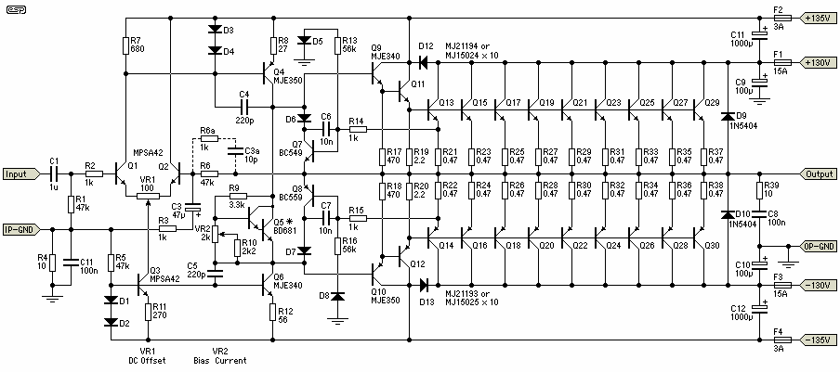
Figure 1 - 1.5kW Power Amplifier
The circuit is completely conventional, using a long tailed pair input stage, direct coupled to the VAS. No current mirror was used for the LTP, as this increases open loop gain and may give rise to stability issues. In a very high power amp, stability is paramount. The amp must never oscillate under any normal load condition, because the heat created can cause almost instant transistor failure.
* Note: It is imperative that Q5 (the bias servo transistor) is mounted on the heatsink, in excellent thermal contact. This is because, unlike most of my other designs, this amp uses conventional Darlington output configuration. It is necessary to use a Darlington arrangement (or a low power Darlington transistor as shown) for Q5 to ensure that the bias remains at a safe value with temperature. This is left to the constructor, because as noted I will not provide technical assistance for this design. There is probably good cause to model and test this aspect of the design very carefully, because it is so important. The arrangement as shown will reduce quiescent current at elevated temperatures. For example, if total Iq at 24°C is 165mA, this will fall to ~40mA at 70°C. This is probably fine, because there is some delay between the a power 'surge' and the output transistors transferring their heat to the bias servo via the heatsink.
The additional feedback components (R6a and C3a, shown dotted) are optional. They may be needed to ensure stability. The output 'flyback' diodes (D9 and D10) will normally only ever conduct if the protection circuit operates while the amp is driving a reactive load. The 1N5404 diodes can withstand a peak non-repetitive current of 200A. Higher rated components may be used if desired. The voltage rating needs to be at least 400V.
The 100 ohm trimpot used in the LTP is used to adjust the DC offset to minimum. With the component values as shown, offset should be within ±25mV, before adjustment. The second trimpot is used to set quiescent current. This should be set to a value just sufficient to minimise crossover distortion. High quiescent current is not desirable, simply because of the power dissipation. Quiescent current is set so that 150mV is measured across R19 or R20.
You will also note that SOA protection has been incorporated. I don't like protection circuits very much, because they can cause very audible sound quality degradation if they operate, but in an amplifier with so many transistors (not to mention the massive power supply needed), the available energy will cause instantaneous destruction of the output stage if protection is not used. Would I actually risk applying a short circuit to the output terminals? No, I would not. I haven't built this design, and I have no intention of doing so. A full simulation tells me that the protection circuits should ensure that nothing blows up, but I do not intend to find out.
Input sensitivity is about 1.77V for 900W into 8 ohms, or 1800W into 4 ohms, or 1.6V RMS for rated power (1.5kW into 4 ohms).
More Power?
Believe it or not, the design can be pushed even further. You will need to add more power transistors and upgrade the power supply though. Supply voltages of up to ±150V can be used without changing anything other than increasing the number of output devices. Although the MJ15024/5 are rated at 250V, they will take more because the base is tied to the emitter with a very low resistance. 1200W into 8 ohms is quite possible, with around 2kW into 4 ohms (or 4kW / 8 ohms in BTL configuration). I suggest that the number of output devices be increased by at least 25% - a total of 13 devices for each supply rail (26 in total, including drivers).
There would seem to be some valid reasons for using MOSFETs, not least because the voltage rating is easily achieved with low cost (switching) devices. The use of high voltage devices with a relatively high RDS_{on} is necessary to minimise distortion at low levels. Given that these usually use the TO220 package, I recommend that peak dissipation is limited to 35W or less (~15W average). The TO220 package is convenient, but is hopeless for transferring significant heat from junction to heatsink. This would require around 50 x TO220 devices for each rail (100 in all). Remember that vertical MOSFETs must be matched, so expect to purchase at least 300-500 transistors to allow for matching. All parallel devices must have as close as possible to the same V_{TH} (threshold voltage, gate to source). Note that a vertical MOSFET version has been simulated, built and tested at lower power (a couple of hundred Watts), but is not shown here.
Given that the peak output power of the amp as described will be around 950W into 8 ohms and close to 1800W into 4 ohms, I doubt that any upgrades will be needed .
2 Ohms?
No. Not a chance. Adding more transistors will certainly allow it - in fact, the transistors there already will come very close. The problem is simply a matter of current. Over 40A RMS at full power just means that large quantities of the output power will be dissipated as heat in connectors and speaker leads, and it's just not worth the effort. Who wants to drag around industrial welding cables as speaker leads? Even at 4 Ohms, you have to deal with over 20A RMS (and 30A peaks), so leads and connectors need to be very robust.

Power Supply
The power supply needed for an amp of this size is massive. Grown welding machines will look at it and cry. For intermittent operation, you need a minimum of a 1kVA transformer (or 1.5kVA for the 2kW version), and it will have to be custom made because of the voltages used. If you expect to run the amp at continuous high power, then transformers should be 2kVA and 3kVA respectively. Filter capacitors will pose a problem - because you need caps rated for 150V, these will be hard to find. Because high voltage high value caps can be difficult to find, it may be necessary to use two electros in series for each capacitor location. This is the arrangement shown. You must include the resistors in parallel - these equalise the voltage across each capacitor so that they have the same voltage. Remember to verify the ripple current rating! This can be expected to be over 10A, and under-rated capacitors will blow up.
Another difficulty is the bridge rectifier. Although 35A bridges would seem to be adequate, the peak repetitive current is so high that they may not be up to the task. I suggest that you use two (or even three) in parallel as shown. The bridge rectifier voltage rating should be a minimum of 400V, and they must be mounted on a substantial heatsink.
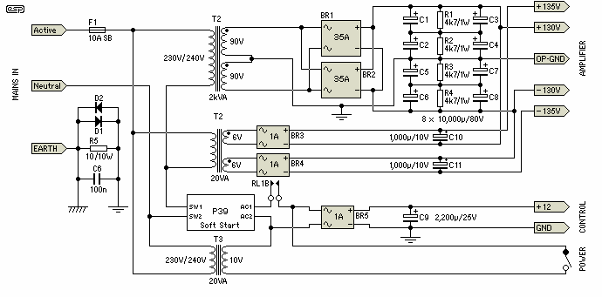
Figure 2 - Power Supply
Note that the supply shown is suitable for one amplifier only! For a stereo version, you will need a transformer with double the rating for a single amp, and double the capacitance. Although a standard P39 soft start circuit controller board will work fine, the resistors will need to be upgraded. The series soft start resistor should be around 33 ohms, and rated at 50W or more. As you can see, the power switch simply applies low voltage AC to the auxiliary supply bridge rectifier and to the soft start circuit via relay contacts. The relay is located on the control board which also has DC and thermal detection.
The additional 5V supplies shown will give a small increase in peak output power, but may be omitted. With the extra voltage, peak power is about 2,048W, vs 1,920W without it. While this may appear to be worthwhile, in real terms it is only 0.5dB more. You will gain far more by using heavier gauge mains and speaker leads or a different power outlet.
DC Protection - You cannot use output relays with this amplifier! Should a DC fault be detected at the output, the only option is to switch off the power. A relay that will withstand breaking 115V or 150V DC at 25A or more is going to be hard to get, and extremely expensive. Although the speakers will be subjected to the full supply voltage until the filter caps discharge, as the builder of the amp, you are confident that they will withstand the power.
Me, I'm not so sure.
You will notice that the AC mains is specified for 230/240V only. Use at 115V is not recommended because of the current. At full power, the amp will draw a minimum of 10A (slightly above the transformer rating), but with 115V, that will increase to over 20A. The losses are too high with that much current, so in 115/120V countries, I suggest that the amp be connected to a two phase power source as a matter of course. Even at the higher supply voltage, the limit for a standard power outlet in Australia is 10A, so the continuous power input is limited to 2400W, and continuous power output will be substantially less than this.
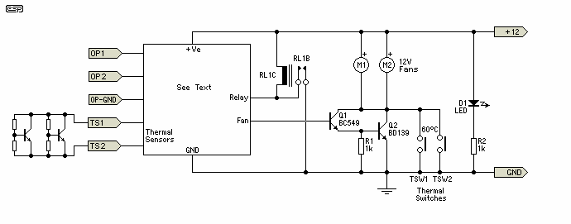
Figure 3 - Protection and Control Circuits
The control circuit need not be complex, but is very important. Although P33 could be used for DC detection, it would be better to use a dedicated circuit (which has not been designed yet). The thermal sensors can be transistors or dedicated ICs, and a simple comparator circuit detects that the temperature is above the trip value of 35°C to turn on the fans. The fans need to be high output types, as they will be called upon to dispose of a prodigious amount of heat when the amp is being pushed. Thermal switches act as a backup - if the fan controller fails to operate for any reason, normally open thermal switches will start the fans.
Water cooling is a viable option for an amp like this, especially for long term high power usage in a fixed location.

Construction
If you decide to build this amp, you will be prepared to spend a lot of money and time. You will also have sufficient experience to be able to work out the construction processes yourself. For a single channel, the parts alone will cost upwards of AU$1,000, probably closer to AU$1,500 or even more. Just the power transformer is likely to be around $250-300, and there's probably another $300 or more for filter capacitors. You will need a heatsink rated at about 0.03°C/W with forced cooling. I cannot suggest a suitable heatsink, but you can be sure that it will be large and expensive.
Please note that this project is provided as information only, and I will not provide any assistance to prospective builders. The entire project is your responsibility if you want to take it on.

Testing
If you are crazy enough to build this amp, then you will have sufficient skills to be able to work out what is needed to test it. Remember that the smallest mistake could easily despatch many expensive transistors, blow the tracks off a PCB, melt wiring, and all manner of other distasteful possibilities.
As with any high powered amplifier, initial testing should be done with a current limited power supply and no load. The amp will be functional with as little as ±10V or less, and the power supply and complete amplifier must be tested using a Variac (bypassing the soft start for initial tests). The Variac needs to be rated the same as the power transformer (i.e. at least 2kVA).
I will leave the remainder of the test procedure to the constructor, since the only people who should even attempt building an amp of this power should be very experienced with high power systems. If this does not describe you, then don't even think about it.

