GBAII

Operation Manual

Introduction:

This manual describes the operation and simple servicing of the GBAII & GBA C2E note validators.

The GBAII has been specially designed to fit into all applications previously served by the GBA validator, in Vending, Amusement, Parking and Internet applications. The GBA C2E is a stand-alone validator that has been optimised for low cost applications and will not drive a stacker. Both validators are currently available with Serial (A)/Pulse, CCTalk®, Parallel or RS232 interfaces and has the following features:

- Superior note discrimination
- Up to 16 note x 4 way acceptance
- Accepts notes from 61 to 82mm wide and up to 170mm in length.
- Single note escrow
- Euro Compliant
- Manufactured to ISO 9001 standards
- Simple configuration by use of a config card
- Modular hardware
- 12V (+/- 10%) operation
- A range of stackers (GBA2 only) and accessories
- Easy access to note path for servicing and cleaning.

An optional illuminated runway note guide is available for GBA 2, but comes as standard on the GBA C2E.
Connections:

Please note: care should be taken to avoid reversing the Ground and 12VDC connections, as this will cause damage to the unit.

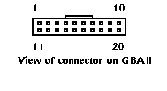

Pin |  | Parallel | Mars Serial | Pulse | Serial (R1)
1 | Grey | /ABN Output | /ABN Output | /ABN Output
2 | Orange |  | /Serial Select (Low) | Pulse (High) or n.c.
3 | White | /Vend 6 Output | /Busy | /Busy
4 | Yellow | /Escrow | Clears /ABN and Stacker Full Signal | Clears /ABN and Stacker Full Signal
5 | Green | / Vend 5 Output | TXD |  | TXD
6 | Brown |  | Serial Send Signal (/RTS)
7 | Black | / Vend 3 Output | Gnd
8 | Red | / Vend 4 Output | Not Used
9 | Whi/Blk/Grn |  | Not Used |  | RXD
10 | Blue | /Enable | /Enable | /Enable
11 | Violet | / Vend 1 Output | Confirm Signal To Start Serial (/CTS)
12 | Whi/Vio |  |  | /Pulse O/P
13 | Whi/Gry | / Vend 2 Output | Not Used
14 | Whi/Blk | Motor Ground | Motor Ground | Motor Ground | Motor Ground
15 | Whi/Blk | Ground | Ground | Ground | Ground
16 | Whi/Red | 12 VDC + | 12 VDC + | 12 VDC + | 12 VDC +
17 | Whi/Red | 12 VDC + | 12 VDC + | 12 VDC + | 12 VDC +
18 | Whi/Yel | PDT Terminal | PDT Terminal | PDT Terminal | PDT Terminal
19 | Whi/Grn | PDT Terminal | PDT Terminal | PDT Terminal | PDT Terminal
20 | Whi/Blu | PDT Terminal | PDT Terminal | PDT Terminal | PDT Terminal

Note: where a description is preceded by a “/” then that signal is active low.
n.c. = not connected

See also Interfaces section for further details

Input / Output Specification

Maximum Output low voltage 0.4V
Minimum Output High Voltage 2.4V

Maximum output sink current 50mA @ 12V d.c.
(Open collector)

Input pull up to 5V 1K ohm

Signal | Description
/ABN (Alarm) | Output – low for 100ms (parallel mode) or Low to indicate error or alarm in serial / pulse mode.
/VEND n | The vend outputs (1 to 6) are capable of sinking up to 50 MA at 12VDC.
/ESCROW | Input - when low this selects Escrow mode
Disable, /Enable | Input - enables the validator when low
PULSE , /SERIAL select | Input - when low selects Mars® Serial (A) mode. High or not connected selects pulse mode
/BUSY | Output – a Low indicates when the acceptor is operating
/DATA | Output - used to send data to the host machine
/CTS | Input - from host that tells acceptor that host is ready to receive the message
/Enable | Input - Determines whether or not the acceptor will accept bills. Logic low = accept bills
/RTS (Interrupt) | Output to host signal that the acceptor wishes to send a message to the host.
/PULSE O/P | The pulse credit output is capable of sinking up to 50 MA at 12VDC.  The pulse pattern is selectable via the programming card. In the normal mode the pattern is 50mS on/300ms off. In the fast mode a 50mS/50mS pattern results.
TXD | Output – open collector
RXD | Input - TTL level RS232 receive data

Absolute Maximum Specifications:

Input Voltage 13.2V
Signal Input High Voltage 5.5V

Minimum Specifications
Input Voltage 10.8V
Signal Minimum Voltage 0V

Environmental
Humidity min 5%
max 95% (non condensing)
Temperature min 0 ºC
max +60ºC

Supply

Voltage 12V +/- 10%
Current consumption
Quiescent 180 mA
Validating 650 mA
Stalled 1.5A

I/O Drivers

Signal interfaces are buffered by use of Toshiba TD6283 or equivalent.

The outputs are open collector.

Inputs:
High > 3.5 V
Low < 0.3 V

6283 Schematic

SERVICING THE VALIDATOR

TO CLEAN VALIDATOR NOTE PATH:

Equipment Required

Cotton Swab or lint free cloth.
Cleaning solution.
A mix of Water and up to 50% Isopropyl Alcohol is recommended.
(DO NOT use more than 50% isopropyl alcohol)
(NEVER use cleaning agents such as “Amberclens” on this product. The unit may be severely damaged)

Procedure;
Anti-Static Precautions should be observed when cleaning validator head.
- Ensure the supply to the validator is switched OFF.
- Disconnect external cables attached to the right (Stacker units only) and left sides of validator head.
- Move the two latches inwards to unlatch and then gently pivot top section backwards to open.
- Using the Cotton swab or cloth dipped in the cleaning solution – carefully clean all sensors and plastic windows using light force only.
- Continue with swab etc to clean note path, all rollers and belts (to advance belts manually rotate the drive gear).
- Use an additional swab or cloth to dry area cleaned, if required.
- Gently push down on the upper section of the reader until the latches re-engage.
- Re-connect external cables.
- The supply to the validator can now be switched ON.

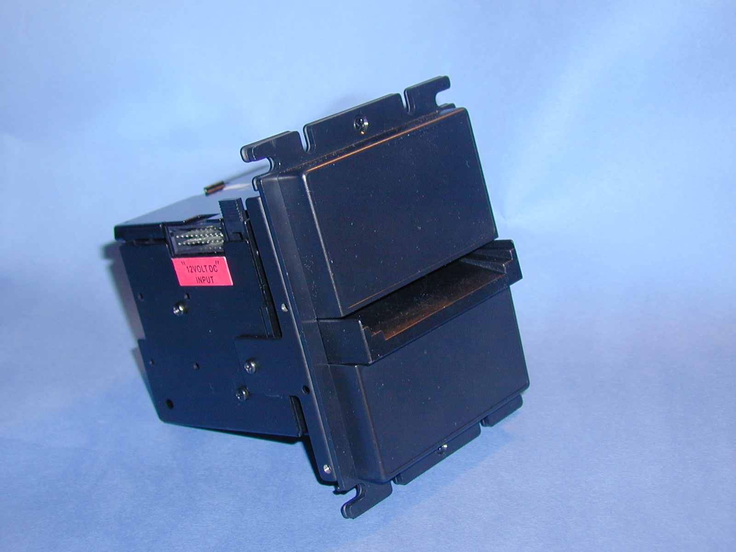
GBAII Reader Head

Jam Clearance:

- Ensure the supply to the validator is switched OFF.
- Disconnect external cables attached to the right (Stacker units only) and left sides of validator head.
- Move the two latches, on the top of the reader, inwards to unlatch and then gently pivot top section backwards to open.
- Clear any debris from note path.
- Re-assemble unit.

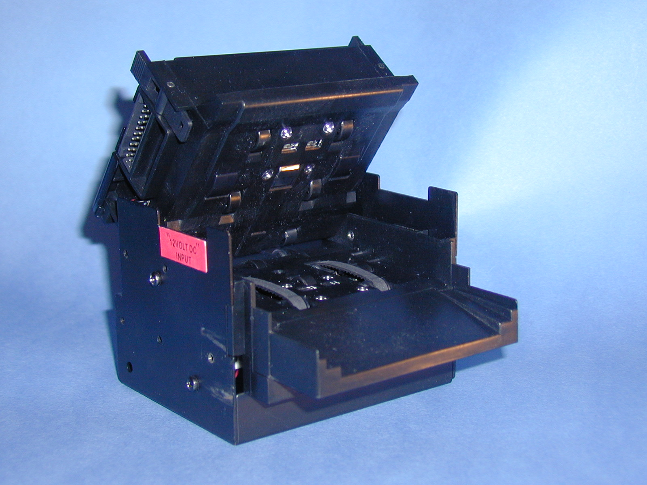
GBA2 in open position for cleaning
CALIBRATION PROCEDURE

Equipment Required;

Stylus with small tip (for switching dip switch)
Calibration Paper. (Thick & Thin)

Procedure;
Anti-Static Precautions should be observed

- The GBAII MUST be powered up for 3 minutes before carrying out Calibration procedure.
- Dipswitch is visible through the top cover window
- Close switch 1 - Dip 1 (ON)
- Insert the first sheet of clean calibration paper (Thin)
- Paper is drawn in fully and then returned approximately 30mm (level with the guide). Here it is held for approx. 3 seconds and then rejected in one smooth movement. If paper is rejected in three movements, insert paper a second time. If paper is still not accepted switch off Dip 1 switch 1, power down the reader and start from point 1.
- After thin paper is rejected insert the second sheet of Calibration paper (Thick) Paper is held for a short period of time and rejected in one smooth movement. If paper is rejected in three movements, insert paper a second time. If paper is still not accepted switch off Dip 1 switch 1, power down the reader and start from point 1.
- Switch off Dip 1 switch 1 and power down the reader.
- Power up the GBAII.
- Calibration is complete.

NB. The GBAII is factory calibrated and should require re-calibration only after the on-board EPROM has been changed.

CONFIGURATION PROCEDURE

Equipment Required;

Stylus with small tip (for switching dip switch)
Program Card. (PC software is available to print these cards. Your distributor is Novo-Parts Kft.)

Procedure;

Anti-Static Precautions should be observed

- Dipswitch is visible through the top cover window
- Close switch 1 - Dip 1 (ON)
- Insert the Program Card into the reader
- If card is read and rejected in one smooth movement, then motor continues to run for a short period, configuration is successful. If paper is rejected in three movements, insert paper a second time. If paper is still not accepted switch off Dip 1 switch 1, power down the unit and start from point 1.
- After successful configuration, switch off Dip 1 switch 1 and power down the GBAII.
- Power up the GBAII.
- Configuration is complet
Note: Please ensure the programming card has been printed on a high quality printer with good solid black lines on the card.

CHANGING AN EPROM

Equipment Required;

EPROM removal Tool.

Procedure;
Anti-Static Precautions should be observed when Handling or changing an EPROM.
- Ensure the supply to the validator is switched OFF.
- Slide back the top plate to disengage and lift to remove.
- The EPROM is now visible adjacent to the back of the unit.
- Carefully remove the EPROM using the EPROM removal Tool
- (Hold board down adjacent to the EPROM socket when removing the EPROM to avoid stressing the mounting)
- Insert new EPROM with pin 1 to pin 1 of the socket. Both the EPROM and socket have a small dimple in the end to denote the location of Pin 1.
- The power to the validator may now be switched back on.
- Calibrate the validator (see calibration procedure)
- Replace the top plate.

CHANGING NOTE GUIDE PLATES:
(To Accommodate Other Currencies)

- Remove the 4 mounting bracket screws (1 on each side / 2 on the bottom).
- Remove from mounting bracket.
- Remove 3 note guide screws located on the bottom of the plastic note guide plate.
- Move the two latches inwards to unlatch and then gently lift to open.
- Gently lift up and pull note guide plate to remove.
- Insert new note guide plate. NB. Some Note guides have arms that fit inside the reader; these arms have locating ribs that must be placed into the corresponding recess inside the reader. If incorrectly fitted, the reader top section will not close properly.
- Gently push down on the upper section of the reader until the latches re-engage.
- Replace 3 note guide plate screws on the bottom of the plastic note guide plate.
- Replace mounting bracket and screws.

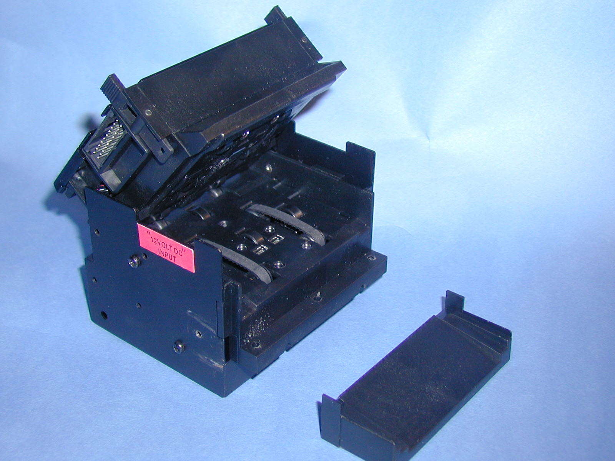GBAII with note guide plate removed

Runway Note Guides for GBAII

An illuminated runway note guide is available in UK and US form. Please consult factory for details.

Illuminated note guide connections:

Pin 1 (Black Wire) 0Volts
Pin 2 (Red Wire) 12V d.c.
Pin 3 (Yellow Wire) Control

Control < 0.5V = Off
Control > 3V = On

Options:

All of the options below can be set using the GBA2 Talk program on PC or with the Program card facility. Two kinds of program card are available. Firstly a card to set all options (all options must be specified) and secondly a specific option card that will set only security level, CCTalk® Encryption Key, Note enable / disable or the use of the magnetic head facility.

Security: Selectable from four levels:

- Low For use in applications, which are not at all security sensitive and require maximum acceptance rate.
- Standard Normal security level for non-Gaming applications. Target acceptance levels normally 95%
- High Normal Security level for Gaming / AWP applications
- Highest Special security level normally reserved for particular applications

Use Magnetic Sensor (firmware 0216 onwards)

For currency sets that have magnetic information the GBA2-C product has the option of turning on or off the magnetic sensor. When this option is used some degradation in acceptance may be experienced for older or damaged notes where the magnetic signature has been worn or destroyed.

Stacker:

The GBA2 can be set for use with the following stackers:

- No stacker
- Vertical Vault
- Up / down vertical stacker
- Horizontal Vault & HNLD
- WGBA*
- HLRC

*Note While the software is compatible; GBA2 is not compatible with WGBA. A special validator is required. Please contact Technical Support for details.

Interface:

The GBA2 can be set for use with the following interfaces:

- Mars® Serial / Pulse
- Parallel
- RS232
- Reserved
- CCTalk® Non Encrypted 1
- CCTalk® Encrypted1
- Parallel XT

Definitions can be found in the interface description section

CCTalk Encryption Key Reset: (Firmware 0230 onwards)

Should a validator require replacing in a CCTalk® application, the Encryption key will require resetting to the default in both the host machine and the note validator. This is achieved, on the note validator, by use of the CCTalk Encryption Key Reset Programming Card using the procedure described above, in “Configuration Procedure”. For resetting the host machine please refer to the machine user guide.

For firmware’s prior to 0230 the encryption key reset is performed via the CCTalk emulator tool.

Escrow Time out period (Parallel mode only):

This option enables the Escrow time out period to be set in 1-second intervals between 1 and 255 seconds. Please Note: The standard escrow time is 30 seconds. Adjust with care! The host machine must be designed to work with any other time selected. Please contact Technical support for more details.

Low Power Mode: In this mode the quiescent current drawn by the unit is reduced by:

(a) The motor power up check is disabled.
(b) The sensors are turned off after a note is validated.

This mode is designed to enable the GBA2 to be used in Battery applications.

OASG: The Optical Anti String Gate detects the presence of material likely to be interfering with the secure operation of the unit. In the event of a situation being detected that could be a fraud attempt; the note is rejected. If the number of consecutive string attempts exceeds a predefined limit, the unit will inhibit acceptance for a user selectable period of time. The system works by shining a beam of light across the note path after the main sensors have been cleared. Care must be taken in mounting the unit to ensure direct sunlight cannot reach the OASG sensor otherwise spurious alarms could be generated.
There are two options associated with the OASG (from Firmware 0218 onwards)

(a) The Number of String attempts before lockup.

This option can be set between 0 and 255. As the name suggests, the unit will inhibit acceptance after the limit is reached for a period of time defined by Lockout Period. When set to 0 the unit will not lock out nor will an alarm be generated.

(b) Lockout Period.

The time in Seconds that the unit will inhibit acceptance, following the detection of the required number of string attempts.

Diagnostics:

Introduction:
The GBA C2E and new GBA2’s, from Q1/2003 onwards, will be supplied with new design micro boards with the facility to communicate validator status by the use of a bi-colour (Red / Green) LED. The following functionality describes the operation of the LED when fitted with firmware Version 0230 onwards.

The LED will be visible through the calibration switch hole on the GBA2.

LED Functionality :
The LED communicates validator status. This enables better diagnostics for the user and for Astrosystems personnel when talking to customers over the phone or by email.

Normal Run Mode:
The LED will be permanently Green (solid on)

If a note is rejected a flash code is given (LED Flashed off):

If the note is rejected due to: No of flashes (led goes off)
Unrecognised note 1
OASG Reject 2
Returned (due to escrow or SW inhibit) 3
Note slip during validation 4

Validator Inhibited by Host:
If the host inhibits the unit then the green LED will flash slowly (rate 0.5Hz, approx 1 sec on / 1 sec off)

Fault Conditions:
Are communicated by turning the LED Red.

Fault LED State
Stacker full or Jam Solid Red LED
Cashbox not present Slow Flashing Red (approx. 0.5Hz)
OASG Lock out Fast Flashing Red (approx. 1 Hz)

Order of precedence of Error Codes:
There may be situations where more than one fault/operating condition is applicable, in which case the order of precedence of displaying the codes is as follows:

- Note Jam / Stacker Full (solid red)
- Anti-String Gate Lock-out (fast flash red)
- Calibration Mode (flash red / green)
- Cash Box Missing (slow flash red)
- Validator Master Inhibit On (slow flash green)

Calibration Mode
When the calibration switch (SW1) is in the “on” position and the unit is powered up, the LED will flash the Firmware revision level (see below) followed by an alternate Red / Green (1Hz) flash to indicate the unit has entered calibration mode.

When the calibration switch is turned on while the power is on, then calibration mode (Red / Green (1Hz) flash) is entered directly.

Should calibration fail then the following codes should be given after the switch 1 is returned to the off position:

1 second off time then:
Cause Flash
IL Fail Three green followed by one red
IR Fail Two green followed by one red & one Green
VL Fail Two green followed by two red
VR Fail One green followed by one red & two Green
UR Fail One green followed by one red, one Green & one red
UL Fail One green followed by two red & one Green
DR Fail One green followed by three red
DL Fail One red followed by three green
OAS Fail One red followed by one green, one red & one green
Mag Fail One red followed by two green & one red
Calibration Aborted Four red

Then 1 second off – the unit will then go back to run time status indication.

Other Faults:
EEPROM checksum error red, red, green, green
External RAM error red, red, green, red

Firmware Revision Level:
The validator will signal the current firmware version after the unit is switched on and the Calibration Switch is turned on*, as follows:

Red LED will flash as a delimiter before each character.
Green LED will flash the individual numbers of the revision code.
There is no red flash at the end, but there is a one second delay before the Green / Red flash LED comes on to indicate “Calibration” mode status.
For zero, there will just be 2 consecutive red flashes.

If the cal switch is returned to its “off” position during the display of the revision level, the display will continue and the validator will enter normal run mode following the 1 second delay at the end

Example:

When the validator signals 0224:

The LED will flash…

R R G G R G G R G G G G
0 2 2 4

Revision | Date | Created By | Approved by | Comments
1.20 | 02/10/2002 | A Walsh |  | Reformatting of operations manual
1.21 | 17/10/2002 | J Bailey |  | Added C2E features and Diagnostics

Contacts:

Novo-Parts Kft. HUNGARY
Telephone: +36 (1) 417-3468
Fax: +36 (1) 410-0438
E-Mail: Novo-Parts Kft.

Note CCTalk is a registered trademark of Money Controls Ltd.
1 Note: CCTalk interface requires the use of a dedicated interface harness. Please contact your distributor or Astrosystems Ltd. for details.
1
* Note Firmware version 0227 indicated revision on power up, regardless of the status of the calibration switch. Firmware version 0227 would not display revision if the validator were in low power mode.

