Infrared Light Barrier
Posted by electrolover in Controllers & Sensors, DIY, House | no responses
This infrared alarm can be used to detect persons passing through doorways, corridors and small gates. The transmitter emits a beam of infrared light which is invisible to the human eye. The buzzer at the output of the receiver is activated when the light beam is interrupted by a person passing through it.
The transmitter and receiver circuits shown here have been designed for a range of several meters, almost independent of ambient light conditions. Only in the rare case of the receiver sensor being exposed to bright, direct sunlight, some screening measures have to be added.
The transmitter does not emit a continuous infrared signal, Rather, it is modulated, that is, the 36-kHz carrier used to pulse the IRED (infrared emitting diode) on and off is itself switched on an off at a rate of about 300 Hz. The reason for doing so is that most infrared sensors, including the ones suggested in the diagram do not respond very well to continuous incidence of infrared light. Switching the IR source off, even for a small period, allows IR detectors to ‘recuperate’, and so optimise their ability to minimize the response to ambient light.

Infrared Light Barrier Transmitter circuit

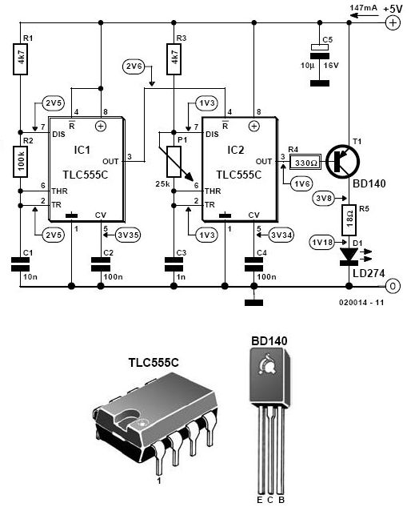
The transmitter consists of two oscillators built around the ubiquitous 555 IC. Here, the current-saving CMOS version TLC555 (or 7555) is used. Alternatively, the two 555’s may be replaced by a single TLC556 (or 7556). IC1 is the 300-Hz generator, IC2, the 36-kHz source. The IRED type LD274 is pulsed at a relatively high peak current via driver transistor T1. If in your application the distance covered by the IR beam is relatively short, the value of resistor R5 may be increased to save on current consumption. Preset P1 is adjusted for a carrier frequency of 36 kHz exactly (failing test equipment, adjust it for optimum range).

Infrared Light Barrier Receiver

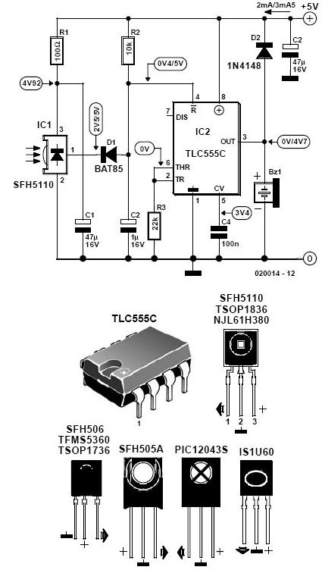
The receiver is equally simple and also based on a CMOS 555. As long as the sensor picks up infrared light from the transmitter, the reset input of the 555 IC is held low and the buzzer is silent. Components D1 and C2 act as a low-frequency rectifier to cancel the effect of the 300-Hz modulation on the transmitter signal. When the infrared light beam is interrupted, the oscillator built around the 555 is enabled and starts to produce a warning tone.
Finally, the test values indicated in the circuit diagram are average dc levels measured with a DVM, under light/no light conditions. In fact, most test points carry rectangular or sawtooth waveforms.

