Mechanically scanned laser display

Project documentation

- Principles

The key of a scanned display is the scanning method. The basic of this scanned laser display is a laser beam which is reflected by rotating mirrors giving a raster. The laser beam is modulated under PIC16F877 control and a stable image can be obtained.
The working principle can be seen in the below drawing.

- Mechanical and optical description

The mechanical parts are a cassette player motor and an octagonal prism with mirrors.
Nothing special about the motor, the speed of motor is not stabilized because the microcontroller measures the speed and makes the necessary corrections.
A picture showing the project and the parts identified by red text is given:
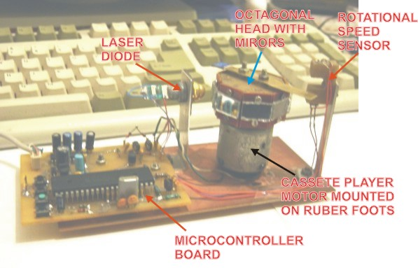
The special thing in this project is the octagonal prism detailed in the next drawing. All dimensions are in mm.

Each face corresponds to one horizontal line in the raster.
Each face is placed on a different angle by using the springs pressure and two screws which are used to adjust the distance between the horizontal lines.
The different angle gives different reflection angles of the laser beam in vertical plane.
In the bellow picture is shown how the prism is divided in 8 sectors and the correspondence between the sectors position and the raster lines.

- The microcontroller board

The heart of this board is a PIC16F877 microcontroller running at 20MHz.
The block diagram is:
The Microcontroller board receives one pulse per rotation from the rotational speed sensor and calculates very precisely the moment for turning on/off the beam.
The power supply and motor supply block takes the input voltage (9-15Vdc) and prepares two voltages: 5V for the electronics and 3V for the motor.
4 keys are used to switch between the displaying modes (normal, mirrored, pause, display of current rotational speed) and for initial calibration of each line.
The RS232 interface provides the hardware support for PC communication in order to download the messages to be displayed.
There is a RTC (real time clock) and a temperature sensor block which is optional. The purpose of this block is to provide the corresponding data to the microcontroller for displaying. But, because the main goal was to test the possibility to build the display, I didn’t assembled the optional components so we’ll ignore these parts.
The following detailed description uses the schematic:

  - The rotational speed sensor
This is a very simple IR LED coupled with a photodiode and the associated transistors. Nothing is special here. The IR LED is always lighting and the optical contact with the photodiode is obstructed every rotation.
  - Laser driver
Because the laser diode which I used is from a key chain laser pointer, there is no feedback or control of laser beam other than turning on/off. So, the supply voltage is filtered with R1-C1-C2 and the current through laser diode is switched with Q1 by the BEAM signal coming from microcontroller.
  - RS232 interface
It uses a MAX232 IC in a PDIP package (U6), which is very simple and easy to use. The circuit is connecter to the microcontroller with RX232 and TX232 signals and to DB9 connector.
  - PIC16F877microcontroller
First of all, the PIC must have a 20MHz clock because of high precision calculations that must be performed for every pixel. The maximum number of displayed characters depends of PIC speed. The power-on reset is given by R4-C5-D6.
In order to obtain the desired high precision in controlling the laser beam, both CCP (Capture/Compare/PWM) modules available on PIC are used. The CCP1 is used in capture mode to measure the rotation period. To do this the SYNC signal coming from the speed sensor is connected to RC2/CCP1 pin of microcontroller.
The CCP2 is used in compare mode set/clear output on match, turning on or off the laser beam at a pre-calculated moment of time. The RC1/T1OSI/CCP2 pin is the output for the BEAM signal.
Both CCP modules use the same time base: TMR1.
The hardware UART is used to perform the serial communication, so the allocated pins for this are RC7 and RC6.
Four keys are connected to RB4-RB7 which are configured to have internal pull-ups.
The keys are used as follows:
- MODE switch between MIRRORED/NORMAL mode
- SHIFT switch the PAUSE/RUN mode
- MODE+SHIFT toggles between displaying the current rotational speed and the user messages
- UP+DOWN enters the calibration mode. Once this mode is entered, UP+DOWN change the line which is currently adjusted
- UP in calibration mode increments the calibration value for the current line
- DOWN in calibration mode decrements the calibration value for the current line
In the calibration mode the start of each line can be adjusted giving the possibility to align the vertical pixels.
As can be seen there are few used pins of PIC16F877 used and PIC16F876 could also be used. But this is the PIC which I had in my hands.
  - The power supply and motor driver
This block consists in two linear voltage regulators: one for the motor and one for the rest of electronics. It must be two regulators because of the big noise generated by the motor. D4 prevents the reverse input voltage damages. U4 provides 5V for the electronics and U5 – D5 for the motor. D5 is 3 diodes which I used to reduce the voltage for the motor in order to obtain the desired rmp. (2000 rpm = 33Hz scanning frequency). The motor speed can vary as long as the electronics makes the corrections on each rotation so, no speed regulation is necessary for the motor.

The electronics of this project is simple. The big job is performed by PIC16F877 and the challenge was to write the software.

The parts list is:
Item | Quantity | Type | Reference | Part
1 | 1 | C | C1 | 220N
2 | 2 | CP | C2,C8 | 470U
3 | 2 | C | C4,C3 | 15P
4 | 1 | CP | C5 | 22U
5 | 2 | CP | C11,C6 | 47U
6 | 2 | C | C7,C10 | 100N
7 | 1 | CP | C9 | 100U
8 | 4 | CP | C12,C13,C14,C15 | 0.22U
9 | 1 | C | C16 | 0.1U
10 | 2 | DIODE | D6,D1 | 1N4148
11 | 1 | PHOTODIODE | D2 | PHOTODIODE
12 | 1 | IR LED | D3 | IR-LED
13 | 4 | DIODE | D4,D4 | 1N4001
14 | 1 | CONNECTOR | P1 | CONNECTOR DB9
15 | 1 | T | Q1 | BC337
16 | 2 | T | Q3,Q2 | BC171
17 | 1 | R | R1 | 10
18 | 2 | R | R8,R2 | 100
19 | 1 | R | R3 | 5.6K
20 | 1 | R | R4 | 10K
21 | 1 | R | R5 | 2.2K
22 | 1 | R | R6 | 8.2K
23 | 1 | R | R7 | 100K
24 | 4 | R | S1,S2,S3,S4 | SW
25 | 1 | IC | U2 | PIC16F877-20/P
26 | 2 | IC | U4,U5 | LM78L05AC/TO92
27 | 1 | IC | U6 | MAX232CPE
28 | 1 | XTAL | Y1 | 20MHz

All parts are through hole parts with no special requirements.
The PCB:
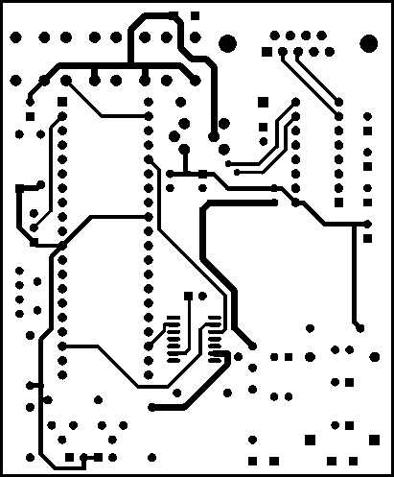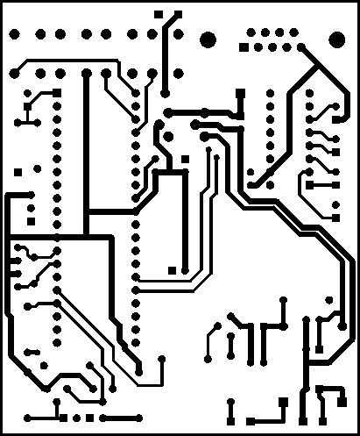
TOP SIDE BOTTOM SIDE
Assembly drawing:
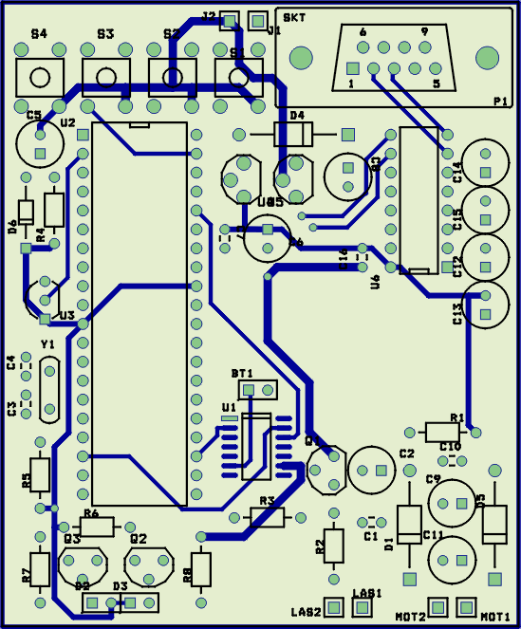
- Software description

  - General considerations
The software is divided into the following sections:
- the main loop (main)
- the interrupt service routine (isr)
- displaying effects functions (grouped in the “effects.c” file)
- serial communication functions (grouped in the “uart.c” file)
Definitions (as is the meaning in this document):
- Message is the piece of user text to be displayed with a specified effect
- Show means all the user messages in the user whished order
The flash memory is divided in three parts:
- 0x0000-0x1000: program space
- 0x1000-0x1800: show space, I used the internal flash memory to store the messages to avoid an external memory. The self writing feature of program memory space is very useful for this purpose. The show space is covered by a const string called “show”, uninitialized at the compile time.
- 0x1F00-0x2000: bootloader space. During the development phase I used a bootloader in order to have easier program update.
The messages are stored in the next format:
HEADER(1byte) | MESSAGE | EndOfMessage(1byte)

There are two important strings which are used for data preparing and are declared in RAM:
- “disp_mirror” – display mirror - which keeps the characters to be displayed
- “ldimage” – laser display image – which keeps a binary image of the display. Each vertical line corresponds to a byte in this string. For example one character occupies have 7x5 pixels which means 5 used bytes + 1 byte for guard. Because of banked PIC memory, one string can have maximum 96 bytes. But for 20 characters are necessary at least 20x6=120bytes. So, I used 2 strings (ldimage1+ldimage2) to store the entire binary image of the display.

The internal EEPROM memory of PIC16F877 is used to store the calibration data for each line. The addresses are 0x00-0x07.

I used the PICC compiler from HI-TECH (version 7.87PL2) with one source file passed to the compiler driver (other files are included). The compilation is performed by launching the “compile.bat” file which executes the compiler driver with the parameters contained in the “ldisp.cmd” file.
  - The main program loop is a software section that performs few “organizational” jobs: launch the PC communication function, to prepare the data for the display, various tasks. The software is “interrupt driven” which means that the most important tasks are performed when interrupts appears.
The initial configuration of the PIC is performed by the “device_config” function which sets the ports direction, configures the CCP modules, interrupts and the UART.
CCP1 is configured in capture mode on every rising edge. The corresponding interrupt is enabled in PIE1 giving an interrupt at each rotation. CCP2 is configured for compare mode clear output on match. The configuration is changed for every pixel in the ISR depending if the pixel must be on or off. If must be on, the configuration will be compare-set output on match. The corresponding interrupt is enabled in PIE2 only after all the calculations are ready.
The USART is configured for 19200bps, 8bit for data, no parity, asynchronous mode. The interrupt on receive is enabled in order do detect when the PC wants to communicate.
The flowchart of the main and the initial setup is:

  - The interrupt service routine
There are 5 used interrupts CCP1 capture, CCP2 compare, TMR1 overflow, PORTB change and serial receive interrupt.
    - CCP1 capture interrupt is used to measure the speed of the motor. The current value of Timer1 is added with Timer1 extension to have a very precisely measurement. Then if the measured period is in the limits accepted as good the first calculations are performed. The “pixel_prep” function called here will be discussed lather. The relationship between the microcontroller frequency, speed and the measuring result is:
period=(f/4)*(60/rpm).
For example: speed=2000rpm, f=20MHz, period=150000.
    - CCP2 compare interrupt is used to precisely turn on or off the laser beam. Because the data must be processed very fast, once this interrupt is entered, the microcontroller stays here until the current line is finished. The fist pixel is displayed using the settings from the pixel_prep called previously. The rest of pixels are prepared here: the compare mode is set according to the current pixel value (1 or 0) to set or clear the output on match. After displaying an entire line, the current line is changed and the data for the next line is prepared by calling the pixel_prep function. The next drawing shows an image about how the tasks are performed.
    - TMR1 overflow interrupt serves to precisely measure the period by incrementing the Timer1 extension: “count”. This technique extends the resolution of TMR1 to 32 bits (only 24 are used, the MSB is 0).
    - PORTB change interrupt is intended to handle the keyboard. The action corresponding to the pressed key (keys) is performed after all the keys are released. During pressing, the PORTB value is and-ed in the ex_portb variable (of course after debouncing) and after releasing, the ex_portb is analyzed, taking the corresponding actions.
    - Serial receive interrupt takes the received byte and if it corresponds to the expected start of communication sets a flag and stops the TMR1 for freezing the displaying of messages. During the communication is not necessary to display messages. The PC communication protocol is discussed separately.
The pixel_prep function makes the preparations for the first pixel of each line. The initial value for which CCP2 is calculated, and the CCP2 interrupt is enabled. Because all the data preparations for effects must be done without affecting the displaying of pixels, all those preparations are made in the dead times after a rotation completed. So the flag for the next step oft the current effect is turned on.

The buil_image function takes the characters beginning with the character pointed by the nextcar and bulds the binary image of the display in the ldimage string. The function uses the char_map constant string to take the image of each character.

The serial communication is very simple, the main developing effort being focused to make the displaying stable and reliable.
The protocol is:
PC sends the start of comm
byte
the device responds with an
acknowledge byte
PC sends one verification
byte
PC sends one data byte
the received
data is End Of
Transmission?
EXIT
YES
NO
In order to achieve the possibility to send the data to the laser display and to prepare the show, the PC must run the application called “Display Constructor” (also developed by me, special for this project). The main window of this application is:
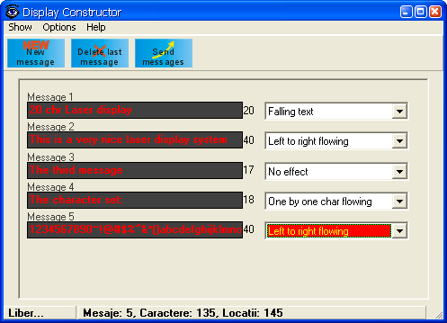

Final words

The project has reached the goal: to demonstrate the possibility to build such a display. The octagonal head was made by hand, with very low precision, with hard work. With a good head (manufactured by a machine) and a stronger laser beam, al very large display can be obtained. Of course, the project can be improved:
- a wireless connection with the PC can be added
- the number of effects can be increased
- the maximum number of characters can be increased by adding an external memory
I think the obtained results are extremely spectacular compared to the very low price of the system.

