16 LED-es futófény

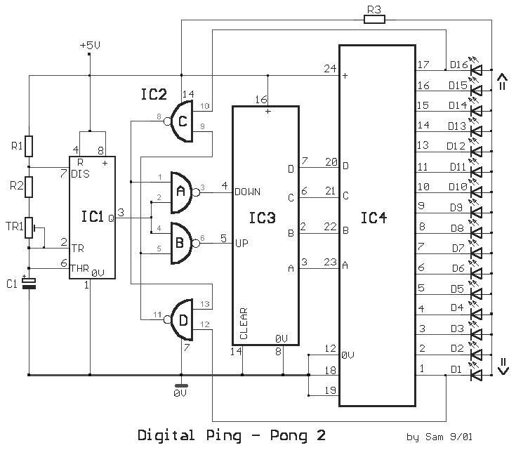

This circuit is a double direction flash. Similar to Digital Ping- Pong 1, there is a movement of a lit dot, up and down along the LED's length. When the D16 lit the situation changes and there is a reverse movement. Lit D15-14 ……D16, is lit making circles when the circuit is under power. The IC1 is an unstable flip- flop supplying with stable frequency pulses (the frequency can be changed by TR1, adjusting the velocity of the LED's up and down). This frequency supplies the IC3 (which is a 4-Bit UP and DOWN counter) through 2 gates A-B of the IC2. The output counter supplies the IC4 that is the driver of the LED's. The parts C- D of The IC2, make a R-S flip- flop, that changes situation, when the edge LED's D1 and D16 lit. We have an electronic limit for the situation change. In proportion the shape we make with the LED's, we can have the proportionate optional result, making various effects.
Part List

R1= 100Kohms | C1= 330nF 100V MKT | IC3= 74193
R2= 220Kohms | D1-16= LED 5mm | IC4= 74154
R3= 470 ohms | IC1= 555
TR1= 1Mohms | IC2= 7400

