Audio Amplifier 100W or 130W
Output can use 2(out=90W) or 4(out=130W) audio power transistors.
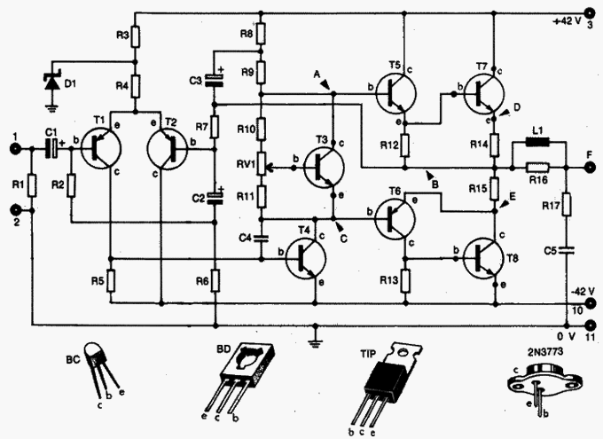

PCB and layout
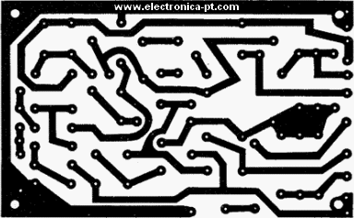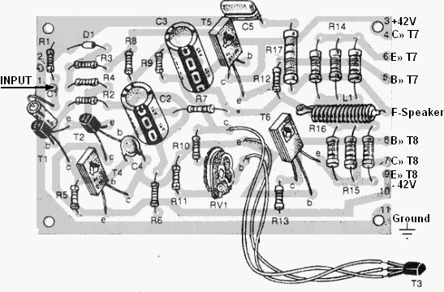
Use T3 on Heatsink
Component | Ref./Value | Type
R1 | 120K | 1/4W Resistor
R2 | 3K3 | 1/2W Resistor
R3 | 5K6 | 1/4W Resistor
R4 | 3K3 | 1/4W Resistor
R5 | 680R | 1/4W Resistor
R6 | 120R | 1/4W Resistor
R7 | 3K3 | 1/4W Resistor
R8 | 1K2 | 1/4W Resistor
R9 | 2K7 | 1/4W Resistor
R10 | 1K5 | 1/4W Resistor
R11 | 680R | 1/4W Resistor
R12 | 120R | 1/4W Resistor
R13 | 120R | 1/4W Resistor
R14 | 0,33R | 5W Resistor
R15 | 0,33r | 5W Resistor
R16 | 10R | 1W Resistor
R17 | 10R | 1W Resistor
C1 | 10uF | 16V Electrolytic Capacitor
C2 | 330µF | 16V Electrolytic Capacitor
C3 | 470uF | 35V Electrolytic Capacitor
C4 | 150pF | Ceramic Capacitor
C5 | 100nF | 100V Polyester Capacitor
RV1 | 1K | Trimpot
D1 | 9V1 - 500mW | Zener
T1 | BC557 | PNP transistor
T2 | BC557 | PNP transistor
T3 | BC548 | NPN transistor
T4 | BD137 | NPN transistor
T5 | BD137 | NPN transistor
T6 | BD138 | PNP transistor
T7 | 2N3773 | NPN transistor
T8 | 2N3773 | NPN transistor
L1 | coil | largest number of turns rolled in R16 with AWG22
Az AWG22 kb. 0,6mm-es huzalnak felel meg

Power Supply
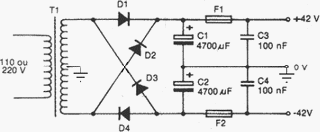 | 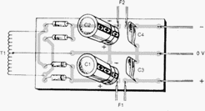

Component | Ref./Value | Type
T1 | 30+30 - 3,5A | Transformer
D1-D2-D3-D4 | Rectifier 5A - 150V | Diode
C1-C2 | 4700uF | 50V Electrolytic Capacitor
F1-F2 | 3A | Fuse
C3-C4 | 100nF | 100V Polyester

Audio Output and Heatsink
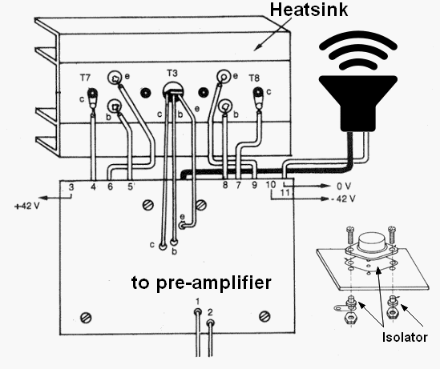

4 transistors 130 W
