E88CC
6922
R.F. DOUBLE TRIODE
DIMENSIONS AND CONNECTIONS:
base: NOVAL
U_{f} = 6,3 V
I_{f} = 365 mA
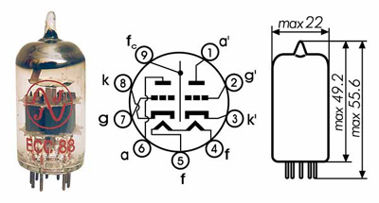

TYPICAL CHARACTERISTIC:  CAPACITANCES: | LIMITING VALUES:
  U_{a} | = 90 V
  U_{g} | = 1,3 V
  I_{a} | = 15 mA
  S | = 12,5 mA/V
  R_{i} | = 2,6 kOhm
  µ | = 33
   | system I | system II
  C_{g/k} | = 3,1 | 3,1 pF
  C_{a} | = 0,18 | 0,18 pF
  C_{g/a} | = 1,4 | 1,4 pF
  U_{a0} | = 550 V
  U_{a(Ia=0)} | = 400 V
  U_{a} | = 220 V
  U_{a}(W_{ar}<0,8W) | = 250 V
  P_{aR} | = 1,5 W
  W_{g1R} | = 0,03 W
  I_{k} | = 20 mA
  U_{g} | = -100 V
  R_{g} | = 1 MOhm
  U_{+k/f-} | = 120 V
  U_{-k/f+} | = 60 V
  R_{k/f} | = 20 KOhm

