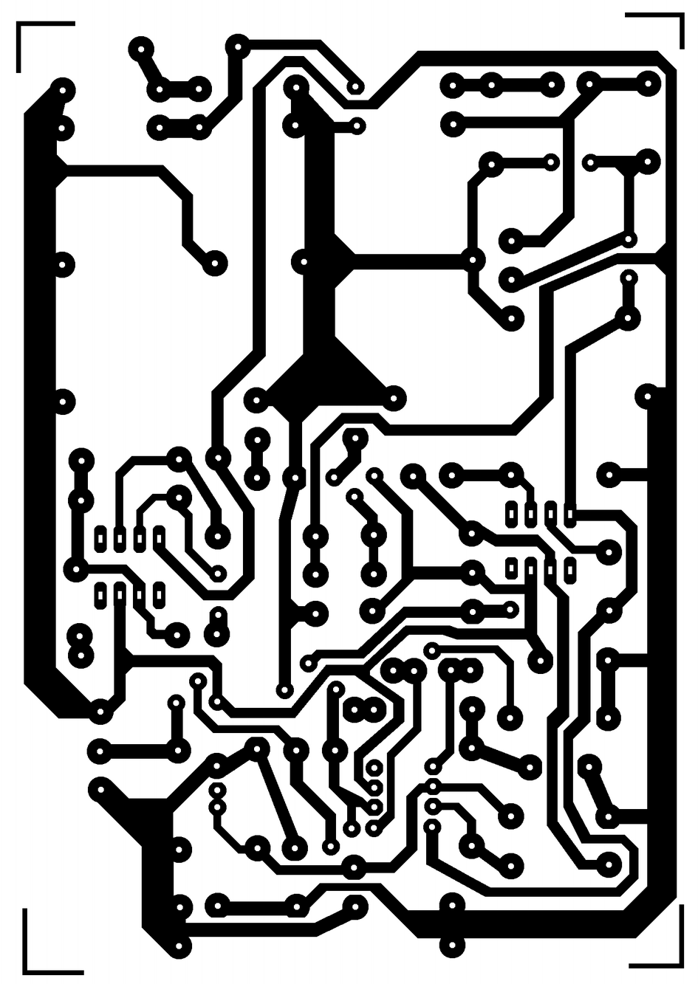
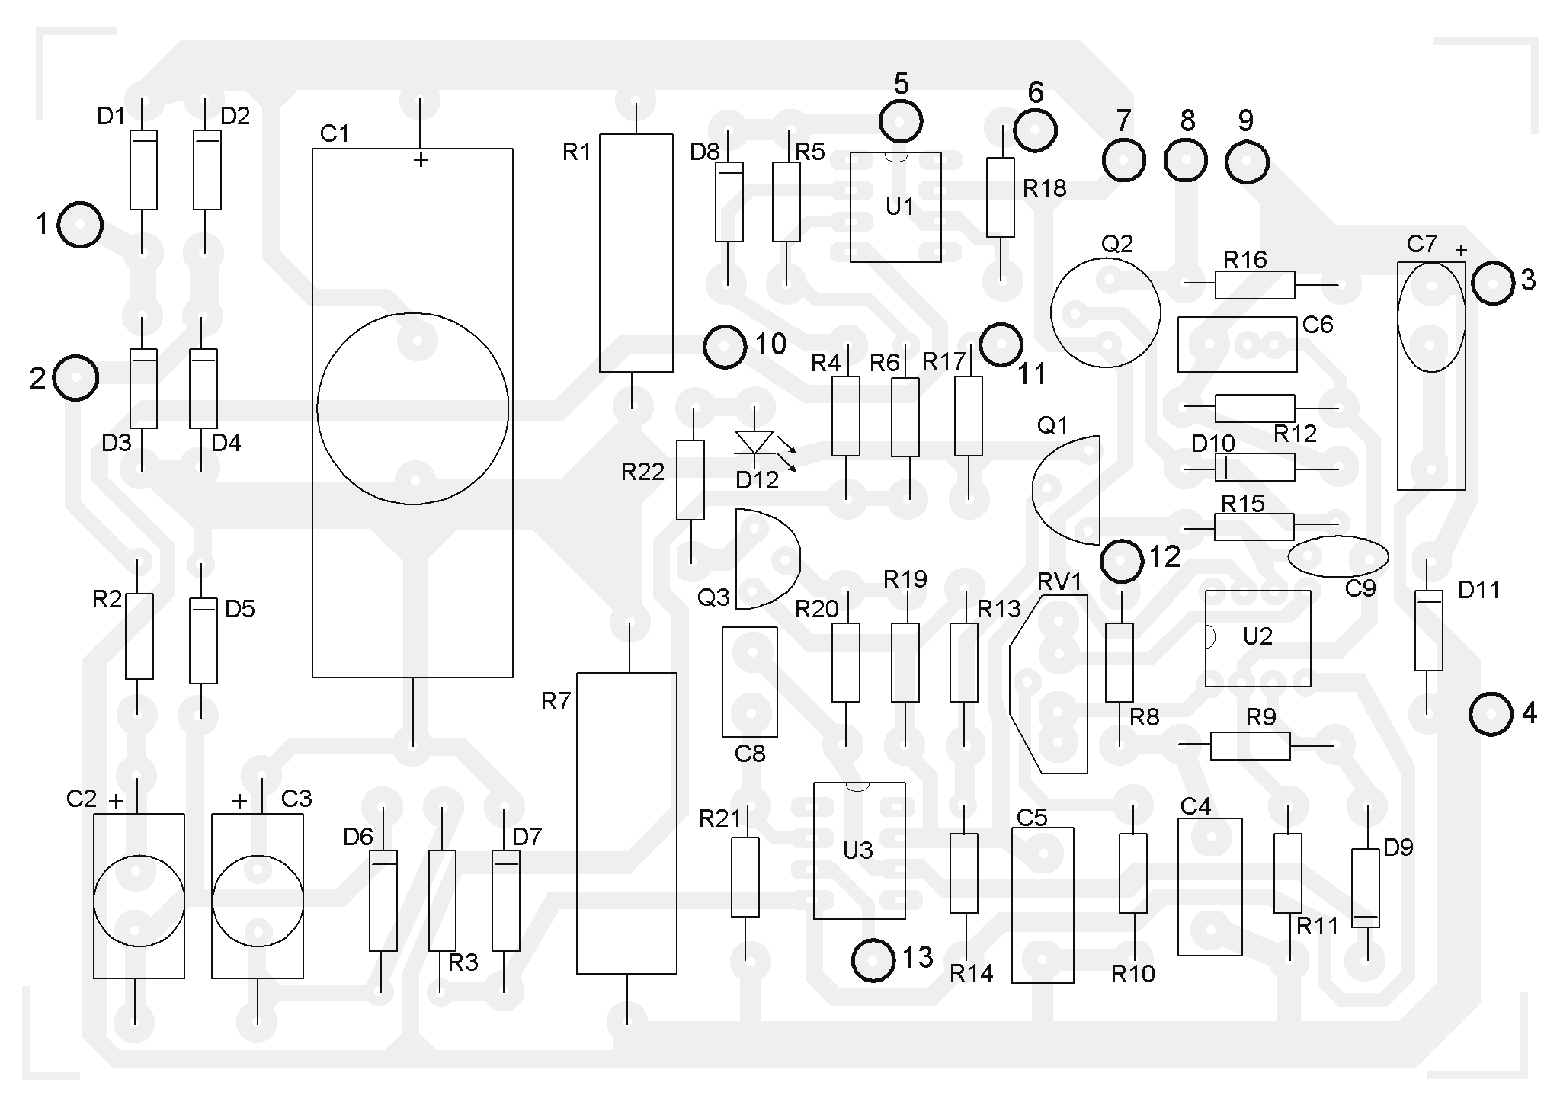

R1 = 2,2 KOhm 1W
R2 = 82 Ohm 1/4W
R3 = 220 Ohm 1/4W
R4 = 4,7 KOhm 1/4W
R5, R6, R13, R20, R21 = 10 KOhm 1/4W
R7 = 0,47 Ohm 5W
R8, R11 = 27 KOhm 1/4W
R9, R19 = 2,2 KOhm 1/4W
R10 = 270 KOhm 1/4W
R12, R18 = 56KOhm 1/4W
R14 = 1,5 KOhm 1/4W
R15, R16 = 1 KOhm 1/4W
R17 = 33 Ohm 1/4W
R22 = 3,9 KOhm 1/4W
RV1 = 100K trimmer
P1, P2 = 10KOhm linear pontesiometer
C1 = 3300 uF/50V electrolytic
C2, C3 = 47uF/50V electrolytic
C4 = 100nF polyester
C5 = 200nF polyester
C6 = 100pF ceramic
C7 = 10uF/50V electrolytic
C8 = 330pF ceramic
C9 = 100pF ceramic
D1, D2, D3, D4 = 1N5402,3,4 diode 2A - RAX GI837U
D5, D6 = 1N4148
D7, D8 = 5,6V Zener
D9, D10 = 1N4148
D11 = 1N4001 diode 1A
Q1 = BC548, NPN transistor or BC547
Q2 = 2N2219 NPN transistor
Q3 = BC557, PNP transistor or BC327
Q4 = 2N3055 NPN power transistor
U1, U2, U3 = TL081, operational amplifier
D12 = LED diode

