--------------------------------------------------------------------------------

Power Line FM Intercom
Ekawahyu Susilo

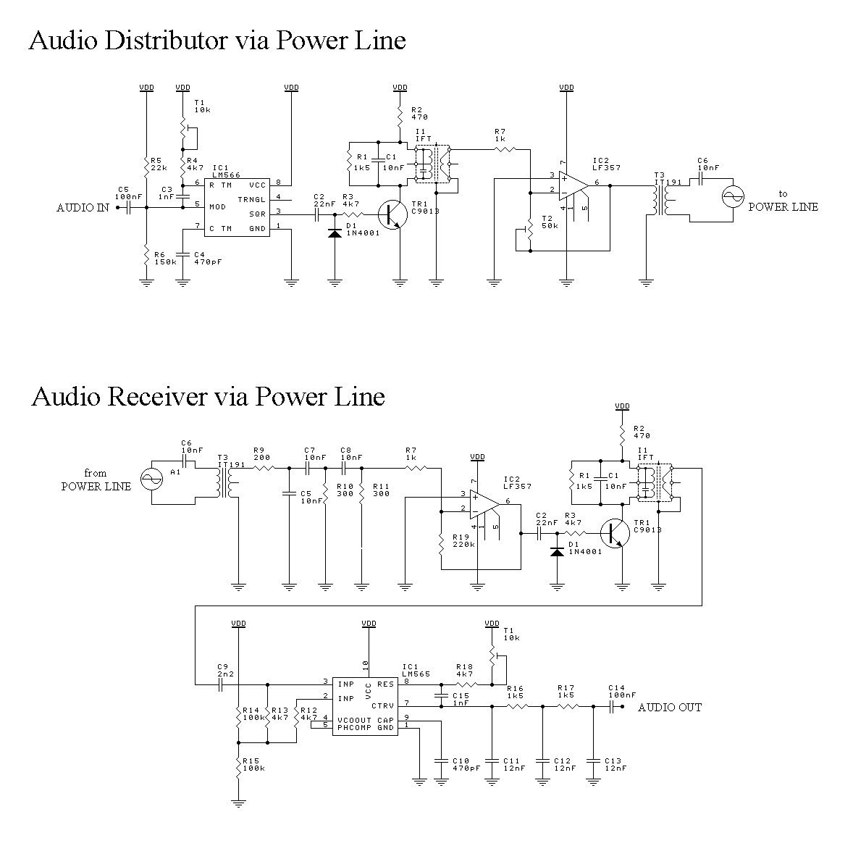

--------------------------------------------------------------------------------

Description: Power Line FM Distributor
Power line is used to transfer electric energy from electric generator to your daily electric equipments.Every building has power line, including your house does. If a building need electric energy, it should get connected to electric supplier (maintain by the state).
You can figure it out that all of buildings are connected through this power line. So, I can say that we've already have a "network" before internet was launched.

The main function of power line is ditributing electric energy. Can we make a new function like sending signal or data? The answer is yes, you can. We can inject a new signal to power line, with your own need. FCC rule said that a range of frequency between 65kHz-75kHz at power line can be used to send data or signal.Here is enclosed my circuit which send audio signal encoded in FM mode through power line and a receiver to decode it from.

Electric power that run at power line has a shape of sinusoide, in electrical ways it contain amplitude and frequency. First, injected signal may not annoying main signal, so you must send as small as possible on. But remember, there are always noises at the line. The point is, you must send a small signal but large enough compared to the noises. The second, use range permitted, that cause a modulation involved. In this case I use frequency modulation methode with 70kHz as the carrier frequency.

Construction

Each component can be constructed at two PCB. One as the transmitter and the other as receiver. You can build more than one receiver, as example, you need to hear music at living room, kitchen, bedroom, etc. Tune potensiometer T1 at both transmitter and receiver to get the same frequency (like tuning your radio). You might need osciloscope to get the exact one. Then trim IF transformer to get best sinusoide carrier. Use 455kHz IF tranformer with yellow painted ferrite core (it frequency has shifted about 70kHz by capasitor parallel at).

Potensiometer T2 to set the amount of carrier level injected at power line. Don't worry about have or don;t have osciloscope. You can set it up by hearing the best sound quality. Just put an audio source at the transmitter and an earphone at the receiver. You might need an amplifier to get louder output.

Happy constructing and don't forget to e-mail me. I'd like to hear from you.

