6AS7GA OTL
Schematic by Bruce Rozenblit (Glass Audio 1990). Power: 35W/16Ohms, 25W/8Ohms, 15W/4Ohms.

Amplifier
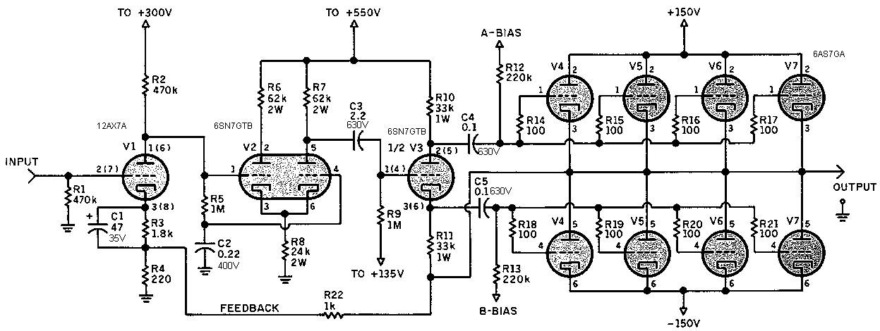

Power Supply, Driver & Bias
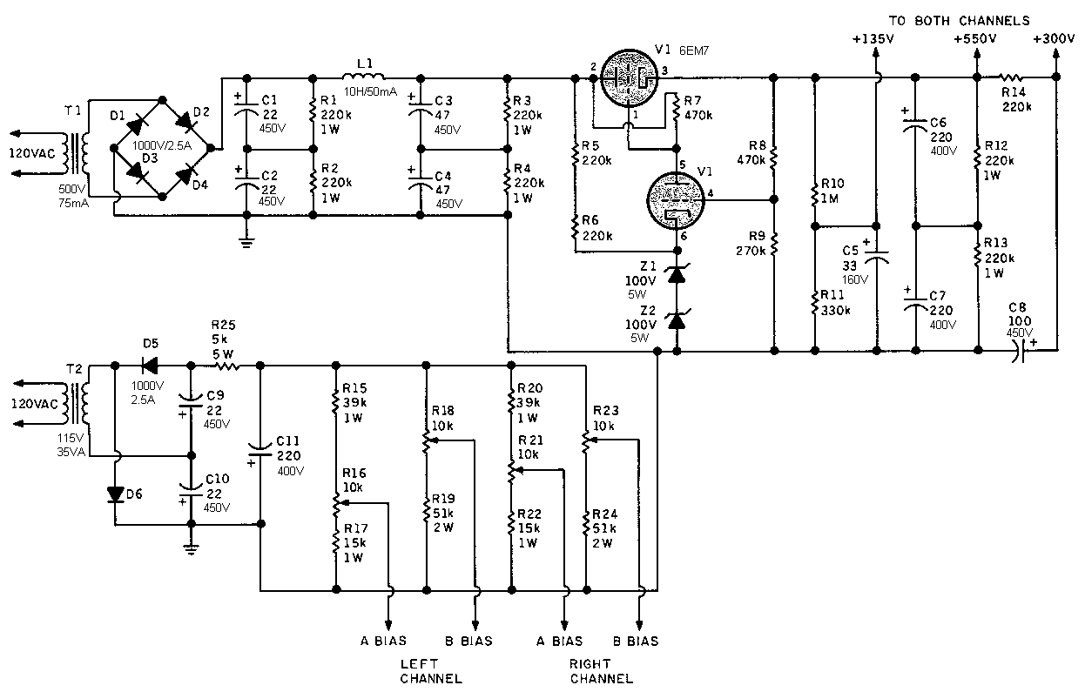

Power Supply, Power Stage
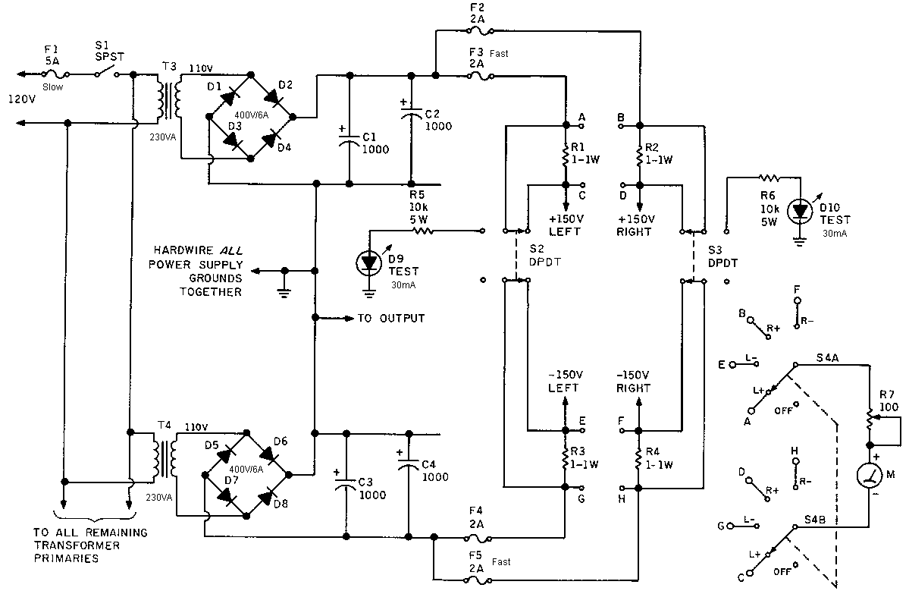

Power Supply, Filaments
